Name: _________________________________________________
Physical Map of Europe Quiz
Directions: Write the number in the space provided that represents the location of each European landform.
_____ Atlantic Ocean

_____ Arctic Ocean

_____ Alps

_____ Pyrenees

_____ English Channel

_____ Mediterranean Sea

_____ Ural Mountains

_____ Iberian Peninsula

_____ Rhine River

_____ Danube River

_____ European Plain

_____ Scandinavian Peninsula
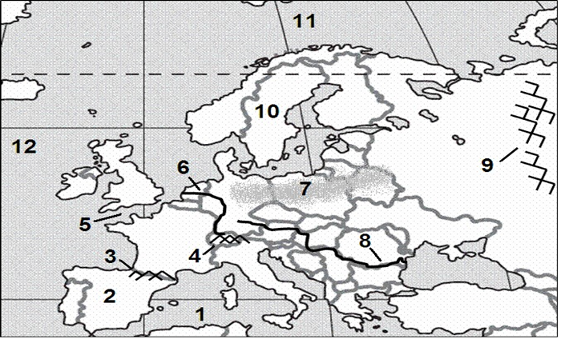

Directions: Imagine that you took a European vacation and followed the path shown on the map to the right. Write a short letter to a friend describing the physical features that you visited or crossed during your trip. Your letter must include:
- At least 4 different physical locations
- Description of that location
- Closing sentence that explains what location you like best and WHY
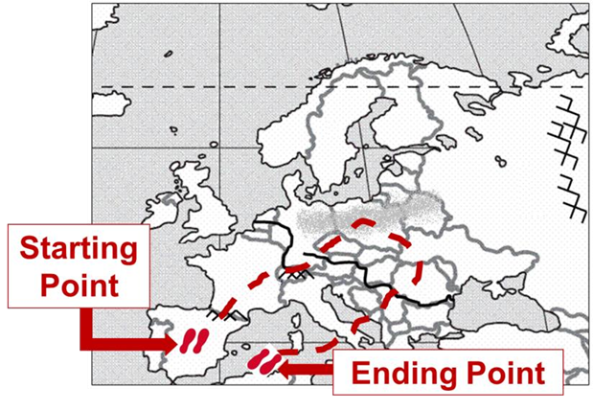
Dear _______________________,
____________________________________________________________________________________________________________________________________________________________________________________________________________________________________________________________________________________________________________________________________________________________________________________________________________________________________________________________________________________________________________________________________________________________________________________________________________________________________________________________________________________________________________________________________________________________________________________________________________________________________________________________________________________________________________________________________________________________________________________________________________________________________________________________________________________________________________________________________________________________________________________________________________________________________________________________________________________________________________Miss you and Wish you were here!
Love, _______________________________________
_________________________________________

