__________________________’ s Family Tree:
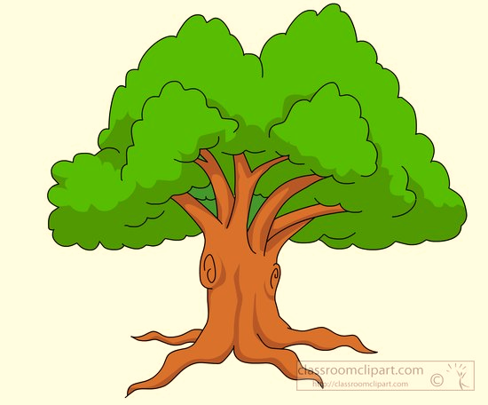

Children
Me

Spouse
Mother

Siblings
Father
Siblings

