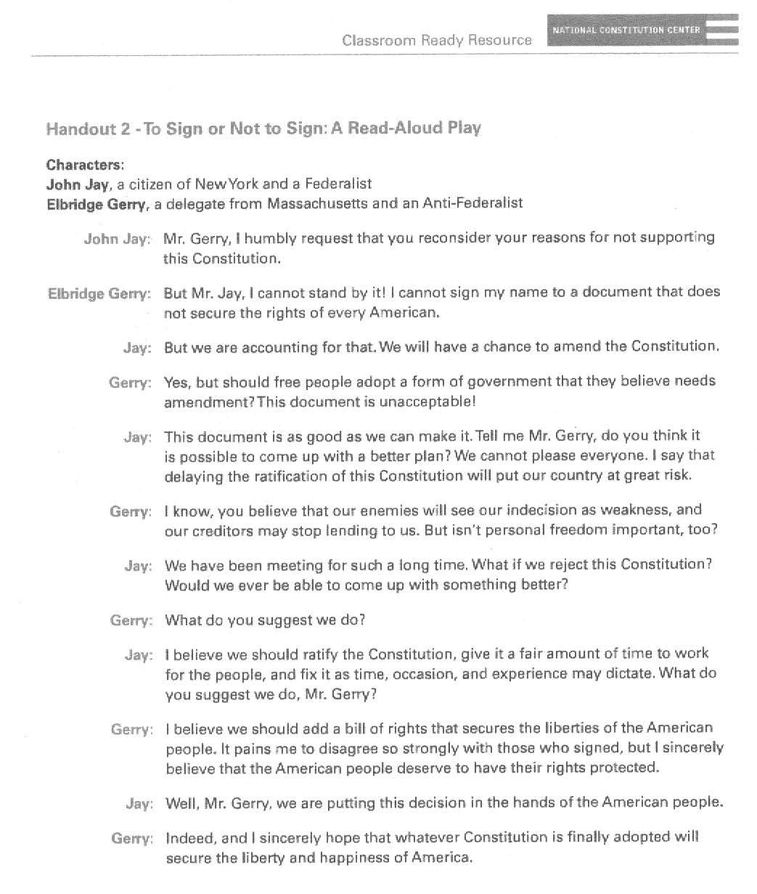

Name: ____________________________________

John Jay and Elbridge Gerry Conversation Questions
Directions: Answer the following questions with your partner.
- What is the strongest reason John Jay gave for signing the Constitution?
____________________________________________________________________________________________________________________________________________________________________________________________________________

- What is the strongest reason Elbridge Gerry gave for NOT signing the Constitution?
____________________________________________________________________________________________________________________________________________________________________________________________________________

- Which delegate do you agree with? Why?
__________________________________________________________________________________________________________________________________________________________________________________________________________
Background Information: For 10 months, Americans argued whether or not to ratify, or approve of the new Constitution. Anti-Federalists did not support the new Constitution but Federalists supported the new Constitution and tried to convince others it should be approved. Below are some of the arguments against and for the new Constitution.
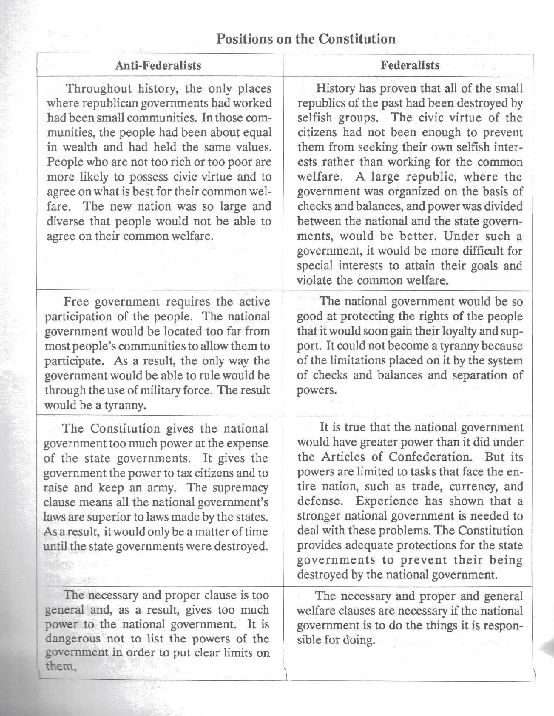

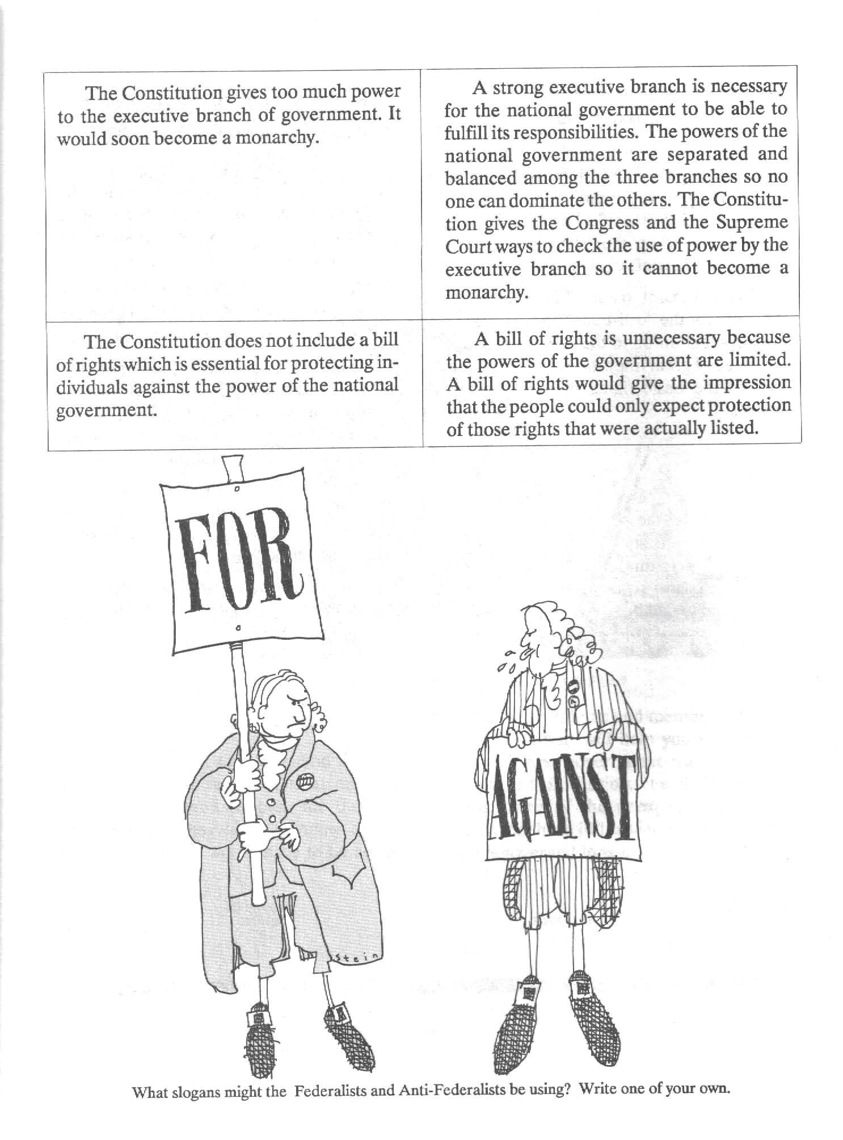
Name: _______________________________________________
Federalists v. Anti-Federalists Arguments

Directions: rewrite the arguments of the Federalists and Anti-Federalists in your own words
Reason # | Anti-Federalists | Federalists
1 | Our country is too big and people’s wealth is too different for us to agree on political issues | People will be divided so it will be too difficult for one group’s interest to come before the common welfare
2 | A free government is requires active participation (voting). Our country is too big for people to be able to participate in a national government. | The national government would work so well that people would support it.
3 | The Constitution give too much power to the national government. It makes national government laws superior to laws made by the states. | A strong national government is necessary to deal with our country’s problems but its power will be limited.
4 | The necessary and proper clause gives too much power to the national government. It is dangerous to not list all the powers of government to make sure they are limited. | The necessary and proper clause is important so the national government can do its job.
5 | The executive branch (the president) has too much power, he would be a king. | The power is split between 3 branches so nobody has all the power.
6 | The Constitution does not contain a bill of rights to protect peoples’ rights from the government. | A bill of rights is not needed because the powers of government are limited. Listing people’s right would make it seem like they only have those rights written.
Ratification is the official way to confirm something, usually by vote. It is the formal approval of proposed law or government document.
Directions: Using the reasons above, answer the questions below.
1. What do you think are the best reasons to ratify or approve of the Constitution?
__________________________________________________________________________________________________________________________________________________________________________________________________________________________________________

2. What do you think are the best reasons to not ratify or approve of the Constitution?
__________________________________________________________________________________________________________________________________________________________________________________________________________________________________________

3. Would you have voted to ratify the Constitution as written in 1787 (without a Bill of Rights)? Explain your answer and provide at least three reasons why you feel this way.
____________________________________________________________________________________________________________________________________________________________________________________________________________________________________________________________________________________________________________________________________________________________________________________________________________________________________________________________________________________

4. Do you think any of these arguments are still important today? If so, which ones and why?
__________________________________________________________________________________________________________________________________________________________________________________________________________________________________________

5. Below write a catchy slogan the Anti-Federalists or Federalists might use to get others to support their side of the Constitution debate. Hint: Think of a short but powerful phrase you might see on a bumper sticker.

Name: _______________________________________

Exit Slip:
Many of the ideas in the Federalist/Anti-Federalist debates seem to some quite relevant today. Some would say it all boils down to a question of the benefits of a strong central government versus states’ rights or the rights of states to make their own decisions. Others would say it is a question of more government controls versus an individual’s personal right to make his or her own decision as to what is best for him or her. After studying both sides of the debates for and against ratification, how do you feel? Based on all that you’ve learned, would you classify yourself as a Federalist or Anti-Federalist and why? If the 1787 Constitution were presented today for ratification, would it be ratified? Why or why not? What issues are still relevant today as in1787? What issues are different?

Directions: Provide your response in paragraph format. Your paragraph should be at least 5 sentences long and answer all questions in bold above.
_________________________________________________________________________________________________________________________________________________________________________________________________________________________________________________________________________________________________________________________________________________________________________________________________________________________________________________________________________________________________________________________________________________________________________________________________________________________________________________________________________

