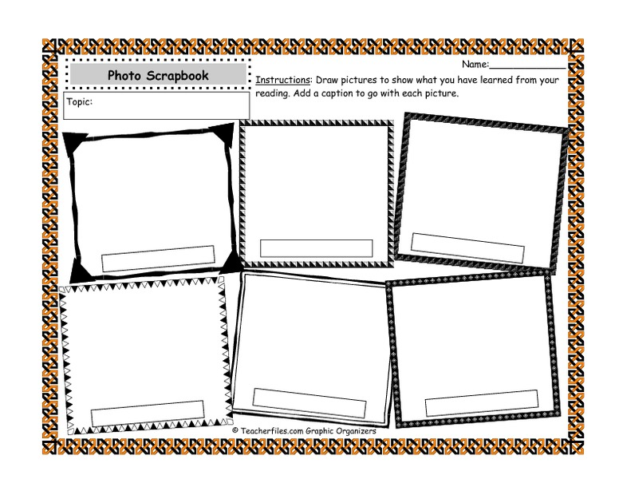

**Instructions: Make a scrapbook of your trip over Africa. Draw pictures to show what you saw on your video tour of Africa and add a caption describing each picture.**

**Flight over Africa**