Name: ______________________________________________________
Geography of India Worksheet
Directions: Use the map on pg. 107 to help you label the map of the Indian Subcontinent
Color Brown: the Hindu Kush and Himalaya mountains
Color Blue: the Bay of Bengal, Arabian Sea, Indian Ocean
Color Green: the Indus and Ganges River
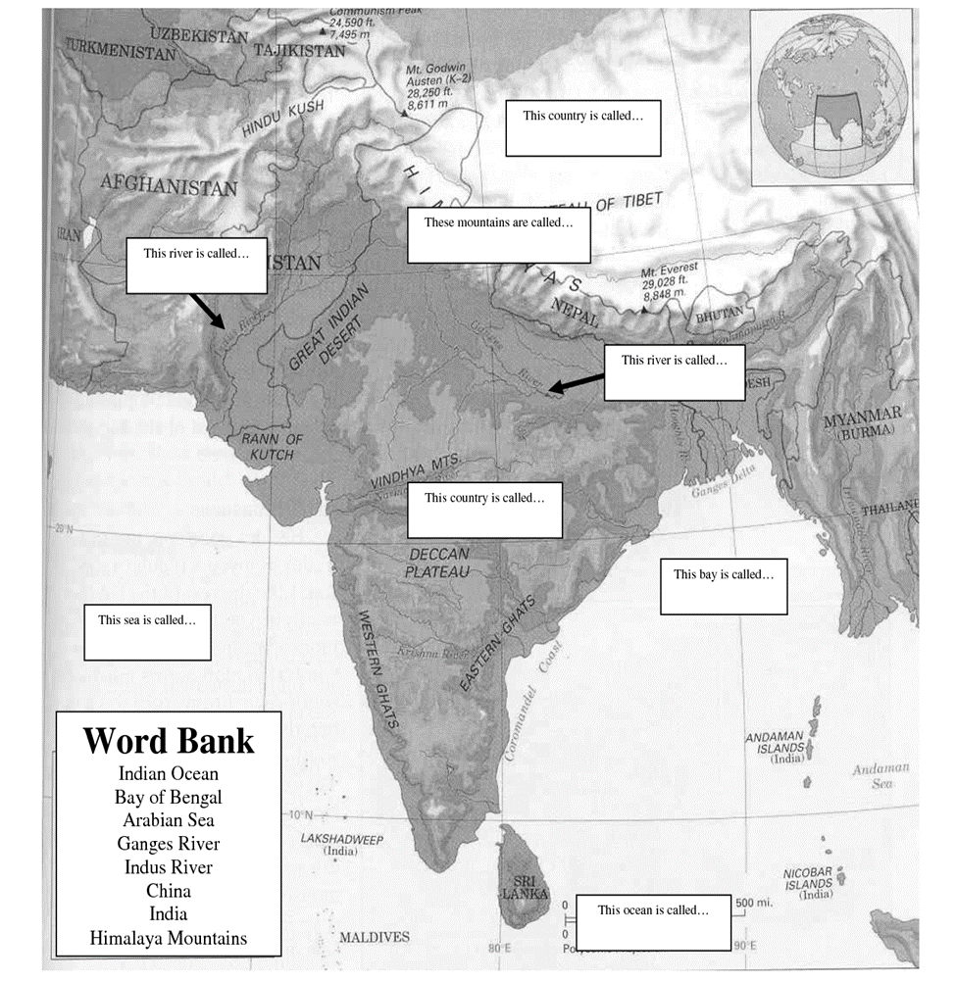

Directions: Define the key terms
1. Subcontinent: _______________________________________________________________________________________
2. Monsoons: _______________________________________________________________________________________

Directions: Answer the following questions
3. What do the Winter Monsoons bring?
_________________________________________________________________________________________

4. What do the Summer Monsoon bring? _________________________________________________________________________________________

5. Why are the Summer Monsoons important? _________________________________________________________________________________________

6. Why are the Summer Monsoons dangerous? _________________________________________________________________________________________

7. What is a mountain pass?
_________________________________________________________________________________________

8. How have mountain passes affected the history of India?
_________________________________________________________________________________________

9. How have the rivers affected the history of India?
_________________________________________________________________________________________

