Name: _______________________________________________
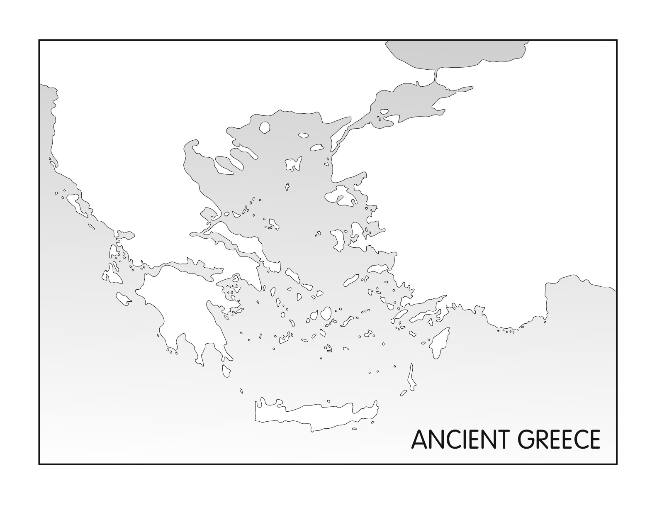
Directions: With your table partner, use the map on pg. 167 to COLOR and LABEL the map on the other side using the steps below. Place a check on each location once it is labeled.

Step 1: Label the following land masses and Color them YELLOW or PURPLE:

_______ Greece
_______ Asia Minor
_______ Crete
_______ Peloponnesus
_______ Macedonia

Step 2: Label the following bodies of water and Color them BLUE:

_______ Aegean Sea
_______ Mediterranean Sea

Step 3: Put a DOT on the map for each of the following city states and write the name of the city- state next to it:

_______ Knossos
_______ Athens
_______ Sparta
_______ Troy
_______ Delphi

