Iceman Artifacts Sheet
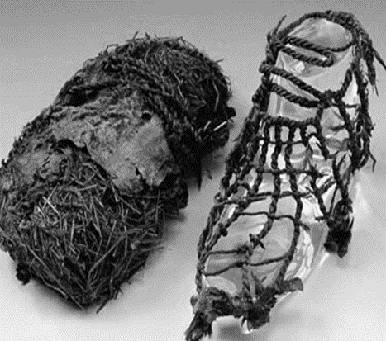  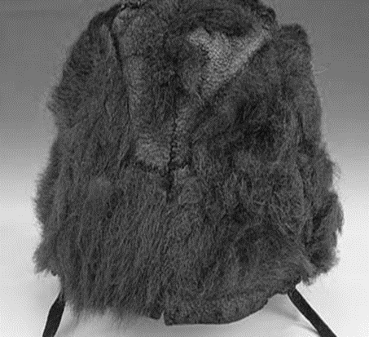 | The Shoes and Hat  Description:  Ötzi’s shoes are the oldest of their kind in the world. The inner shoe is composed of grass netting. Its purpose was to hold hay in place which kept the wearer warm. The outer part is made of deerskin. Both parts – the grass netting and the leather upper – are fastened to an oval-shaped sole made of bearskin by means of leather straps.  The hat, which was worn with the fur side out, was extremely well preserved. On the lower edge, two leather straps were attached which were tied under the chin to keep the cap in place. Both chinstraps were already torn before Ötzi’s death.
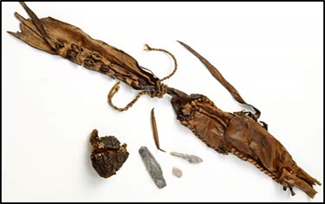 | The Belt and Pouch  Description:  The Iceman’s belt was made from calf’s leather. It was long and could be wrapped twice around the hips and tied.  The pouch was a piece of leather, the opening could be closed with a fine leather string. The Iceman used his belt pouch to store various flint tools: a scraper, a drill and a flint flake which was used to start fires.. A small point bone was also found. It could be used for various jobs from sewing to tattooing, or simply as a toothpick.
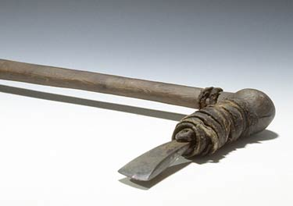 | The Copper Axe  Description:  The most important item of the Iceman’s equipment is his copper-bladed axe. The handle was made of birch wood and the copper blade was fixed to the handle with birch tar and leather straps.
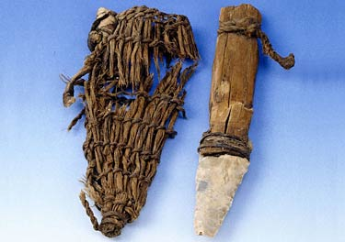 | The Knife  Description:  The knife had a flint (stone) blade and an ash wood handle.  The blade was inserted deep into the wooden handle and bound with animal skins. Blades like this were an important trade item in the late Neolithic Age because of their strength and quality.
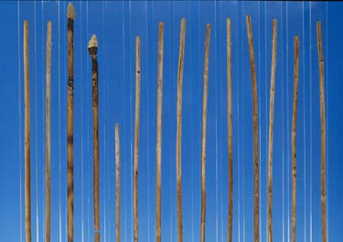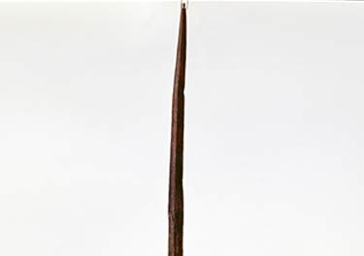  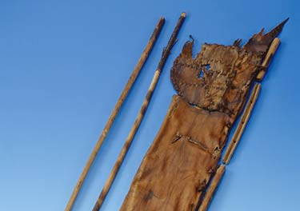 | On Otzi’s bow, the bowstring is was attached to one end of the bow by means of a loop and bound at the other end.  Close examination of the bow revealed that it was covered in blood. When dry, blood acts as a water repellent.  Researchers were surprised when they found only two finished arrows along with a dozen rough arrow shafts.

