Mapping the West: The Journey of Lewis and Clark
In 1803, Thomas Jefferson, bought a large chunk of land from France’s ruler, Napoleon Bonaparte, in what was called The Louisiana Purchase. He bought the land from France for only fifteen million dollars and instantly doubled the size of our country. The land extended from the Mississippi River to the Rocky Mountains, and from the Gulf of Mexico to
Canada. It was a vast wilderness and Americans knew very little about the land that was west of the Mississippi at the time. Therefore, Jefferson asked two men to lead an exploration of that area. Their names were Meriwether Lewis and William Clark.

Jefferson felt that Americans needed to explore their new territory for a few reasons. First, and most importantly, he wanted Lewis and Clark to find a “water route” to the Pacific Ocean
from the Mississippi River. Jefferson knew that if Americans could travel by river all the way west to the ocean, they could settle there and increase trade with Native Americans. Second, Jefferson wanted to claim the northwestern portion of the continent’s midsection before another country did. Jefferson feared the French or Spanish might sail up the Mississippi River from New Orleans and take over our western territories. After the English explorer Alexander Mackenzie went through British America (now Canada) to the Pacific, Jefferson worried about the British, too. Lastly, he thought that knowledge of the area’s geography would be needed for all of the other goals to come true. Jefferson knew that whomever he chose for the exploration would be in for a dangerous trip. In fact, he, along with many others, figured that the west was home to gigantic volcanoes, huge wooly mammoth animals, and a mountain made of pure salt.

Jefferson chose a group of men named The Corps of Discovery and named Meriwether Lewis, a captain in the U.S. military, its leader because he was an expert in surviving in the wilderness and was familiar with the lifestyles of Native Americans. Lewis chose William Clark, his old friend, as his second in command.

In May of 1804, Lewis and Clark and their Corps of Discovery began their journey on the Missouri River, leaving St. Louis and sailing northwest. Lewis’ main job, besides leading the men, was to make maps and charts of the geography of the unknown land. Clark was usually seen studying rocks, plants, and animals along the route.

They had traveled mostly overland from Missouri to what is now the state of Oregon. For much of the trip, they were accompanied by a Shoshone Indian Sacagawea; her husband, Toussaint Charbonneau; and their baby, Jean Baptiste (nicknamed Pomp) . In all, Lewis and Clark traveled for nearly three years . They began in St . Louis in the winter of 1803, headed west to the Pacific, and returned to St . Louis, to cheering crowds, on September 23, 1806 .

During the trip, only one of their men, Charles Floyd died. He became ill and died of appendicitis. They also had to do their best to find food and stay healthy during the winter months. Many Native American tribes disliked the Americans, and Lewis and Clark were headed deeper and deeper into their land. Lewis and Clark were worried there would be battles with the Native Americans.

Lewis and Clark would eventually reach the Pacific Ocean after traveling through several rivers, including the Clearwater, Snake, and Columbia Rivers. However, they did not discover one direct water route that could lead boats straight to the Pacific from the Mississippi.

Still, the trip was an incredible success. They had discovered the Rocky Mountains, which were not volcanoes nor made of salt. Clark and his crew had learned about over two hundred plants and animals that were new to the Americans, though they did not see any wooly mammoths. Lewis and Clark were the first to trade with dozens and dozens of Native American tribes that had never met the Americans before. Finally, Lewis and his men drew about 140 of the first maps of most of the western United States. It has been said that the maps provided a fill‐in of what was mostly a general outline of the area. Therefore, Lewis and Clark made it much more possible for the United States to stretch all the way “from sea to shining sea.”

© 2013 ReadWorks
®
, Inc. All rights reserved.

Name: _____________ Date: _______________________

- Who led an exploration of the land west of the Mississippi River?

  - soldiers from France and Spain
  - Native Americans
  - Meriwether Lewis and William Clark
  - Thomas Jefferson and Napoleon Bonaparte

- Lewis and Clark’s trip was a success.

What evidence from the passage supports this statement?

  - Lewis and Clark’s team discovered the Rocky Mountains, two hundred plants and animals, and drew the first maps of the western United States.
  - Thomas Jefferson wanted Lewis and Clark to find a water route from the Mississippi River to the Pacific Ocean that would increase trade with Native Americans.
  - During their trip, Lewis and Clark headed deeper and deeper into Native American land, worrying that there would be battles with Native Americans.
  - In May of 1804, Lewis, Clark, and The Corps of Discovery began their journey by sailing northwest on the Missouri River.

- Why might Americans have known little about the land west of the Mississippi River in 1803?

  - Forty-eight of the fifty states in the U.S. are “continental.”
  - B Americans had not lived west of the Mississippi River before 1803.
  - Meriwether Lewis was a captain in the U.S. military.
  - Meriwether Lewis and his men drew about 140 maps of the western United States.

- What were Jefferson’s three goals for Lewis and Clark’s trip?

______________________________________________________________________________________________________________________________________________________________________________________________________________________________________________________________________________________________________

- Do you think the Lewis and Clark expedition was a success? Why or Why not?
_____________________________________________________________________________________________________________________________________________________________________________________________________________________________________________________________________________________________
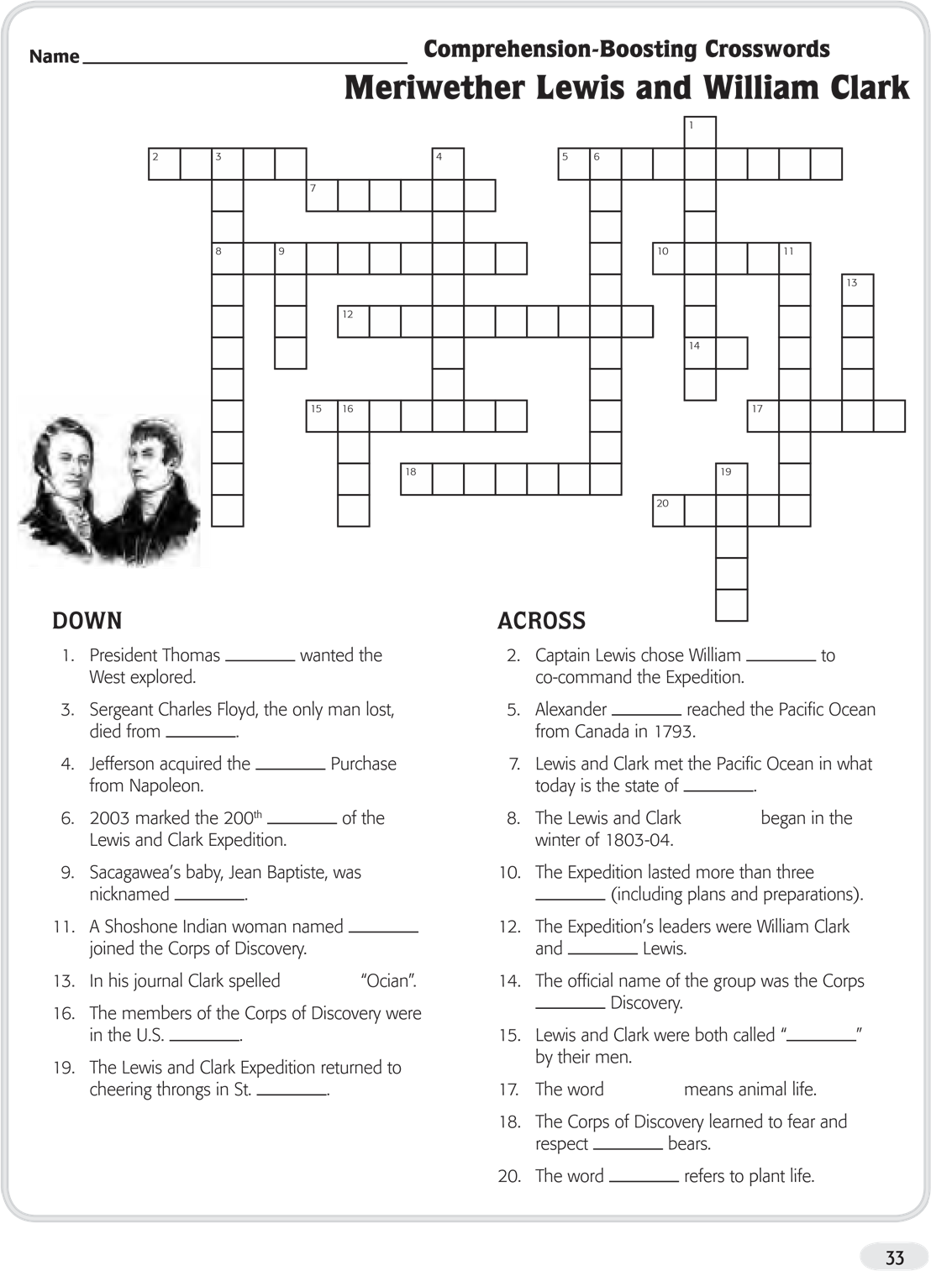

Teacher Guide & Answers: Mapping the West

Teacher Guide & Answers

Passage Reading Level: Lexile 1090

- Who led an exploration of the land west of the Mississippi River?

  - soldiers from France and Spain B Native Americans
  - Meriwether Lewis and William Clark
  - Thomas Jefferson and Napoleon Bonaparte

- Lewis and Clark’s trip was a success.

What evidence from the passage supports this statement?

  - Lewis and Clark’s team discovered the Rocky Mountains, two hundred plants and animals, and drew the first maps of the western United States.
  - Thomas Jefferson wanted Lewis and Clark to find a water route from the Mississippi River to the Pacific Ocean that would increase trade with Native Americans.
  - During their trip, Lewis and Clark headed deeper and deeper into Native American land, worrying that there would be battles with Native Americans.
  - In May of 1804, Lewis, Clark, and The Corps of Discovery began their journey by sailing northwest on the Missouri River.

- Why might Americans have known little about the land west of the Mississippi River in 1803?

  - Forty-eight of the fifty states in the U.S. are “continental.”
  - Americans had not lived west of the Mississippi River before 1803.
  - Meriwether Lewis was a captain in the U.S. military.
  - Meriwether Lewis and his men drew about 140 maps of the western United States.

- What were Jefferson’s three goals for Lewis and Clark’s trip?

Suggested answer: Jefferson’s three goals were finding a water route from the Mississippi River to the Pacific Ocean, claiming the “northwestern portion of the continent’s midsection” before another country did, and acquiring knowledge of the geography of the western United States.

- Answers will vary
2

© 2013 ReadWorks
®
, Inc. All rights reserved.

Answer Key
MERIWETHER LEWIS & WILLIAM CLARK
(page 32)
Down:
1 . Jefferson
- appendicitis
- Louisiana
6 . anniversary
9 . Pomp
11 . Sacagawea
13 . ocean
16 . army
19 . Louis
Across:
2 .Clark
5. Mackenzie
7. Oregon
8.Expedition
10. years
12. Meriwether
14. of
15. Captain
. 17. Fauna
18. grizzly
20 . flora

