Name: __________________________________________ Grade: _______

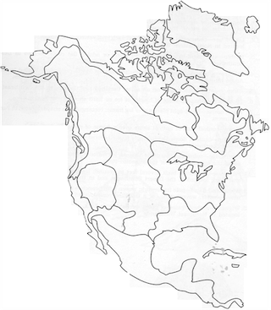Native American Cultural Regions

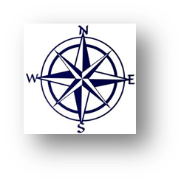

**Map Legend**

Arctic 

California 

Great Basin 

Northeast 

Northwest Coast 

Plateau 

Southeast 

South West 

Subarctic 

**Native American Cultures Presentation Notes**

**INUIT—ARCTIC REGION**

**1.**

**2.**

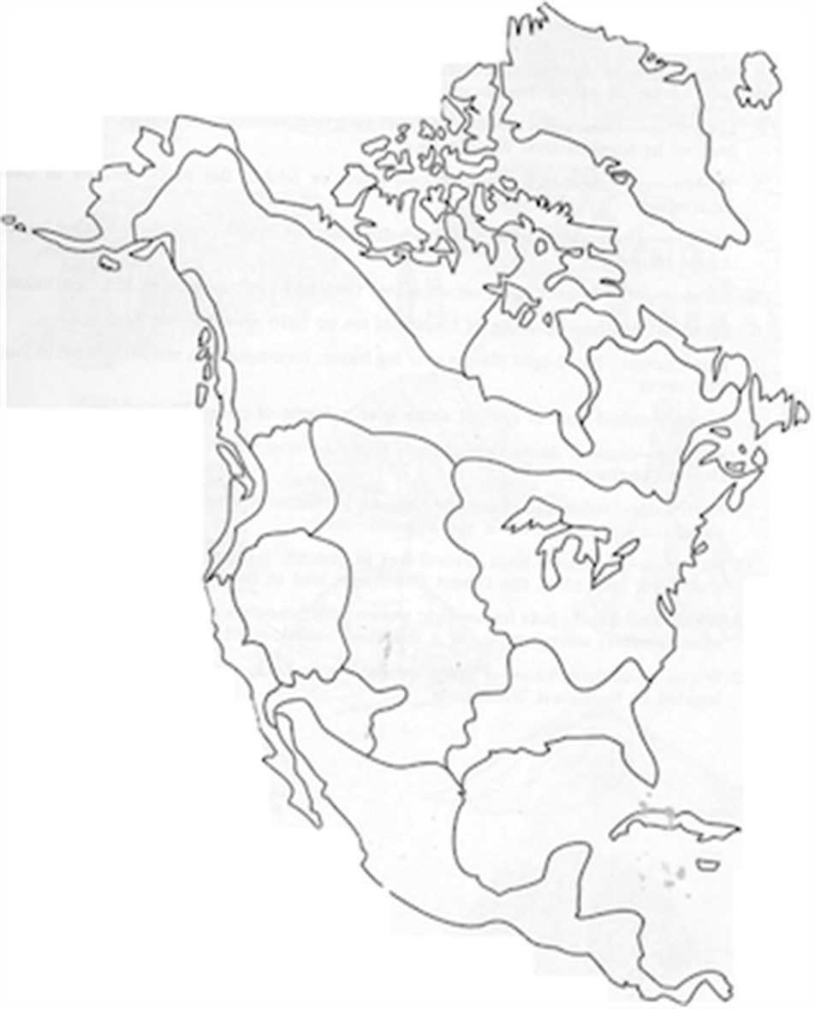

**Sioux – PLAINS REGION**

**1.**

**2.**

**PUEBLO – SOUTHWEST REGION**

**1.**

**2.**

**NEZ PERCE-NORTHWEST REGION**

**1.**

**2.**

**CHEROKEE—SOUTHEAST REGION**

**1.**

**2.**

**SEMINOLES- SOUTHEAST REGION**

**1.**

**2.**

**IROQUOIS – EASTERN WOODLANDS REGION**

**1.**

**2.**