Names: __________________________________________________

Natural Barrier: ______________________________________

Draw a picture of your natural barrier?  Describe your natural barrier | Where is it? | What challenges would you have crossing your natural barrier?
1. Draw picture of your natural barrier.  2. Describe your natural barrier?  ________________________________  ________________________________  ________________________________  ________________________________  ________________________________ | 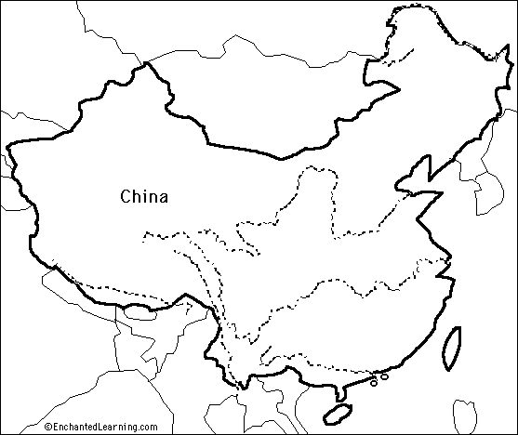  1. Label your natural barrier on the map above.  2.Describe the location (i.e. Northeast, South)  ________________________________________________ | 1. List the problems or challenges you would have if you tried to cross your natural barrier.  ____________________________________  ____________________________________  ____________________________________  ____________________________________  ____________________________________  ____________________________________  ____________________________________  2. Think about what you would have to have  To successfully cross your natural barrier.  ________________________________________  ________________________________________  ________________________________________  ________________________________________

