Ramadan

Muslims have five special duties to perform in their lives known as The Five Pillars of Islam. One of these is Sawm – the duty to fast during the month of Ramadan.

Ramadan is the ninth month of the Muslim Year, but that does not mean that it happens in September. That would be too easy.

So try to keep up: Muslims traditionally follow a lunar calendar. Each month is the amount of time it takes for the moon to go around the Earth, and a year is made up of twelve of these lunar months. The western world generally follows a solar year which is the amount of time it takes the Earth to travel around the Sun once. Because the lunar year is slightly shorter than the solar year, it means that Ramadan will be slightly earlier (by about ten days) in the Western calendar every year. Confused?
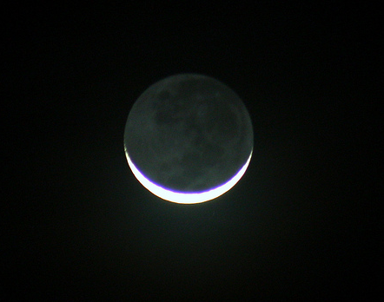
Ramadan begins when the new moon is sighted in the night sky. This will be a thin crescent moon and it means that the fast will begin the following morning. Fasting is compulsory during daylight hours and so Muslims will get up while it is still dark so they can eat. This first meal of the day is known as sehri and must be finished before the first prayer, which is called Fajr and it is said just before the sun comes up.

During daylight hours, Muslims are not allowed to eat, drink, smoke or have intercourse. It is a month when they try to live especially good lives, so they will often try to give up any bad habits and stop doing things they know are wrong. Ramadan is believed to be a holy month when Shaytaan (the Devil) is not allowed to tempt human beings. This means that Muslims have no excuse to act badly. For some this is quite a struggle and they have a name for it: Jihad. This word literally means “to strive” or “to struggle” and describes anything a Muslim has to do for Allah that they find difficult. This will be slightly different for each person: for one person it might be giving up smoking, for someone else it might be giving up swearing, for another it might be giving up spreading nasty rumours.

Fasting is not eating or drinking for a certain period of time. For Muslims, they fast during the daylight for the entire month. Fasting is hard enough in Muslim countries where everyone is taking part, but in Britain and other non-Muslim countries, it is even more difficult because the temptation to eat is all around them.

Even if Muslims don’t usually say the five daily prayers, they often make the effort to do so during Ramadan – Fajr (just before sunrise), Zuhr (after midday), Asr (mid afternoon), Maghrib (just after sunset) and Isha (when it is completely dark).

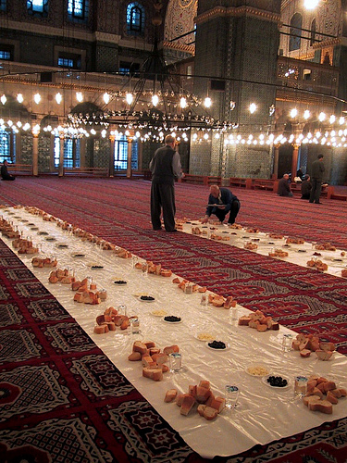
Just after sunset, the Maghrib prayer marks the end of the fast and Muslims can finally eat. This meal is known as Iftar. It is traditional to break the fast with milk and dates because that is what Muhammad used to do and also because immediately consuming a large meal after so many hours of eating nothing could cause a stomach ache. Many people like to gather at home or at a mosque to share the meal together.

So why do it? Muslims give many reasons, but the most important is because they are instructed to fast by Allah in the Qur’an. To fast is therefore an act of obedience and submission to God’s will. Another reason is to be part of the Muslim community. The final reason is so that Muslims can empathise with people who have nothing to eat all year round. At the end of Ramadan, Muslims are encouraged to give money to the poor because having just spent a month knowing what it is like to feel hungry, they are more likely to give willingly and generously.

All adult Muslims have the duty to fast but they are excused if they are physically ill, mentally ill, very elderly, travelling, a pregnant woman, a menstruating woman or a breast-feeding mother. Of these, the elderly, the ill and the breast-feeding mothers should pay for a poor person to be fed for all the days they are not fasting. Travellers should make up the days they have missed at a later date.

Ramadan ends when the next new moon is sighted in the sky, signalling the beginning of Shawwal (the tenth month of the Muslim calendar). The following day Eid ul-Fitr, (which means “the Festival of Fast Breaking”), is celebrated and Muslims can eat normally during the day for the first time in a month.\

On this day, Muslims are encouraged to dress in their best clothes and attend a special Eid prayer at their neighborhood mosque. Before the prayer begins, Muslims make an alms payment, in the form of food or its cash equivalent. This food and/or money is then distributed to the poor. After the special religious service, the focus turns to gift-giving. Children are given many gifts. Women get gifts from their loved ones. Also on this day, people are encouraged to forgive people and settle disputes, especially those between family members.

Name: _________________________________________
Ramadan Comprehension Questions

1. When is Ramadan celebrated? Why does it happened at different times each year?
_______________________________________________________________________________________________________________________________________________________________________________________________________________

2. During Ramadan, Muslims are not supposed to do all of these things during the daylight EXCEPT
a. eat
b. drink
c. talk
d. smoke

3. Ramadan is a holy month, in which people have no excuse to at badly because
a. the devil cannot tempt people
b. the Quran is read daily
c. Muslims are isolated from other people
d. God will punish them

4. What does “Jihad” mean?
a. to struggle
b. to fight
c. to swear
d. to smoke

5. Why is fasting harder for Muslims in non-Muslim countries?

__________________________________________________________________________________________________________________________________________

6. When is not a time that Muslims pray during Ramadan?
a. before sunrise
b. after lunch
c. after sunset
d. after dark

7. Describe the Iftar meal.
__________________________________________________________________________________________________________________________________________

8. Which is NOT a reason Muslims fast?
a. submission to God’s will
b. understand what it’s like to be poor
c. to become healthy
d. to be part of the Muslim community

9. Why are Muslims more likely to give to the poor after the month of Ramadan?
__________________________________________________________________________________________________________________________________________

10. Who is NOT required to fast during Ramadan?
__________________________________________________________________________________________________________________________________________

11. What should the elderly, the ill, and breast-feeding mothers do to make up their fasting?
a. fast as soon as they are able
b. pay for a poor person to be fed
c. pray more than five times a day
d. wait until the next Ramadan to fast

12. During the Eid ul-Fitr, the Festival of Breaking Fasting, Muslims take part in all of the following activities EXCEPT
a. go to Mosque
b. give money/food to the poor
c. forgive people
d. take the day off of work

During Ramadan, Muslims focus on the poor and less fortunate. For that reason, charity is a major activity during the holiday. If you had enough money and time to donate to charity, what charity would you donate your time or money to? Why?

_______________________________________________________________________________________________________________________________________________________________________________________________________________________________________________________________________________________________________

