Name: ________________________________________
World Geography Pre/Post Assessment

1. The _______________________divides the Earth into northern and southern hemispheres.

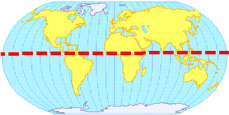
a. Equator
b. Prime Meridian
c. Tropic of Cancer
d. Time Zones

2. What unit is used to measure lines of longitude and latitude?
a. hours
b. percentage
c. degrees
d. centimeters

3. What is the imaginary line of longitude at 0 degrees?
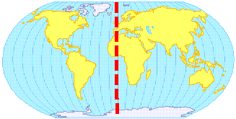
a. equator
b. tropic of Cancer
c. Prime Meridian
d. Time Zones

4. The Equator divides the Earth into halves called ___________________.
a. continents
b. hemispheres
c. islands
d. latitudes

5. A _____________________ is a key that explains what symbols on a map mean?
a. compass rose
b. scale
c. legend
d. title

6. This type of map shows the long-term weather patterns of a place.
a. topography
b. climate
c. political
d. physical

7. This map is a ___________________ map.
a. political
b. climate
c. historical
d. physical
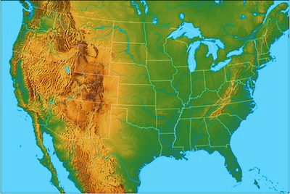

8. The star is located on which continent?
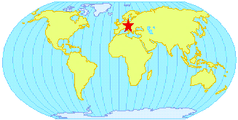
a. North America
b. Asia
c. Europe
d. Africa
Use the map and compass rose below to answer questions 9-11.

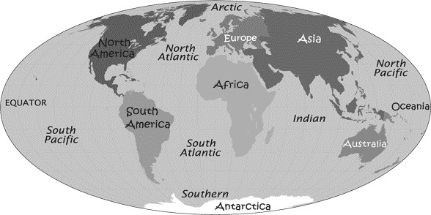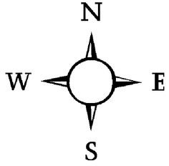

9. Using a compass rose South America is _________________ of Europe.
a. northeast
b. northwest
c. southeast
d. southwest

10. Using a compass rose, Europe is located ___________________ of Africa.
a. north
b. south
c. east
d. west

11. Using a compass rose, Asia is located _________________ of Australia.
a. northeast
b. northwest
c. southeast
d. southwest

12. The further you get away from the Equator the ______________________ it gets.
a. hotter
b. colder
c. wetter
d. drier
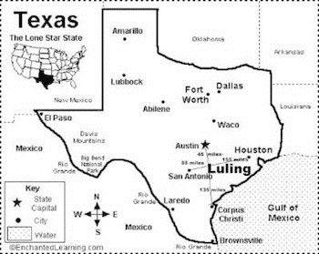
13. What direction would you travel to go to Waco if you lived in El Paso?
a. north
b. south
c. east
d. west

14. A ________________ allows us to see how far to places are apart.
a. legend
b. title
c. compass rose
d. scale

15. Africa, Asia, Europe, North America, South America, Australia, and Antarctica are all examples of _______________.

a. continents
b. oceans
c. countries
d. states

16. The star is located on which ocean?
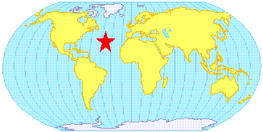
a. Atlantic
b. Pacific
c. Arctic
d. Indian

17. The longest river in North America is
a. Amazon River
b. Hudson River
c. Mississippi River
d. Missouri River

18. A group of places that shares a common features is a:
a. climate
b. region
c. location
d. culture

19. A narrow bridge of land that separates that connects North America and South America is called:
a. Caribbean Sea
b. Central America
c. West Indies
d. Bering Strait

20. What is a human-environment interaction
a. the physical and human characteristics of a place
b. the way people, goods, and ideas move from one place to another
c. the climate of an area
d. the way people use and change their surroundings

21. Relative location is
a. the hemisphere in which a place is located
b. the description of a place using the location of a place nearby
c. the mailing address of a location
d. the coordinates of a location

22. Canada share landforms with its neighbor to the south, _____________________.
a. British Columbia
b. England
c. United States
d. Greenland

23. The exact address of latitude of location is:
a. absolute location
b. relative location
c. direct location
d. place location

24. ________________________ is a way of life. It includes language, clothes, beliefs, and education.
a. culture
b. economics
c. politics
d. religion

25. The four major geographic regions in Africa are:
a. desert, savannah, semi-arid, and tropical rainforest
b. grasses, mountains, valleys, and hills
c. hot, cold, wet, and dry
d. rivers, lakes, marshes, and deltas

26. The Amazon Rainforest in located in
a. Africa
b. North America
c. South America
d. Asia

27. Which river runs through the Sahara desert?
a. Amazon River
b. Nile River
c. Mississippi River
d. Yellow River

28. Where is India?
a. Africa
b. South America
c. Asia
d. Europe

29. Which of these countries is made up of many islands?
a. Australia
b. Japan
c. Switzerland
d. Brazil

30. Which continents are located completely in the Southern hemisphere?
a. Asia and Australia
b. Asia and Antarctica
c. Australia and Antarctica
d. Africa and Australia

31. Greece is located on what body of water?
a. Persian Gulf
b. Caspian Sea
c. Mediterranean Sea
d. Black Sea

32. __________________ are reasons why people want to leave a place
a. pull factors
b. globalization
c. push factors
d. migration

33. ___________________________ is an area of the world where people share similar beliefs, history, and language.
a. cultural region
b. cultural trait
c. civilization
d. geographic region

34. This branch of science is the study of earth and everything on it.
a. archeology
b. geography
c. history
d. anthropology

35. This theme refers to the way that information, people, and goods move from one place to another.
a. place
b. location
c. region
d. movement

36. Transfer of ownership of goods in exchange for something else is called
a. specialization
b. diffusion
c. trade
d. globalization

37. _____________________________ are reasons people want to go to a new place.
a. pull factors
b. globalization
c. push factors
d. migration

38. Which figure is a measurement of how crowded a country is
a. birthrate
b. deathrate
c. population density
d. elections

39. Which is NOT a type of government?
a. democracy
b. authoritarian
c. capitalism
d. theocracy

40. The taking of ideas and traditions is known as __________________________________________.
a. cultural trait
b. cultural borrowing
c. multiculturalism
d. interdependence

41. The state of Florida is known as what type of landform
a. island
b. gulf
c. archipelago
d. peninsula

42. ______________________ create maps for specific purpose
a. Economists
b. Geographers
c. Cartographers
d. Archeologists

43. __________________________ study and interpret human artifacts
a. Economists
b. Geographers.
c. Archeologists
d. Anthropologists

44. What is a historian?
a. a person that studies the past
b. a person who studies earth’s landforms
c. a person who studies climate regions
d. a person who studies global trade

45. What term refers to when there are not enough resources to produce all the goods and services people desire?
a. diffusion
b. specialization
c. scarity
d. trade

