World Religion Map
Directions: Follow the Steps below to complete your World Religion Map
Step 1: Label the continents and oceans using pg. __________________________________________
Continents: Africa, Asia, Europe, Australia, North America, South America, Antarctica
Oceans: Pacific, Atlantic, Indian, Arctic, Southern

Step 2: Draw a compass on the map with the directions: North, South, East, and West

Step 3: Shade in the areas where each world religion is practiced using pg. ________________

- Shade the areas that are predominantly Christian red Christian=follow Christianity
- Shade the areas that are predominantly Jewish purple Jewish=follow Judaism
- Shade the areas that are predominantly Muslim green Muslim=follow Islam
- Shade the areas that are predominantly Hindu yellow Hindu=follow Hinduism
- Shade the areas that are predominantly Buddhist orange Buddhist=follow Buddhism

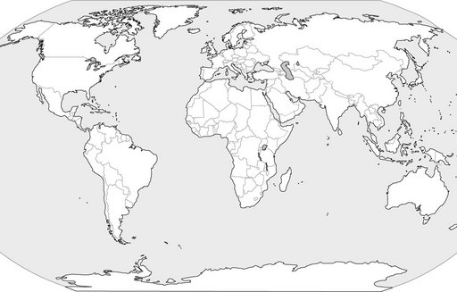
World Religion Map
Map Legend

Christianity

Islam

Buddhism

Hindu

Jewish

