Europe
OLDE WEBQUEST ACTIVITYPACKET
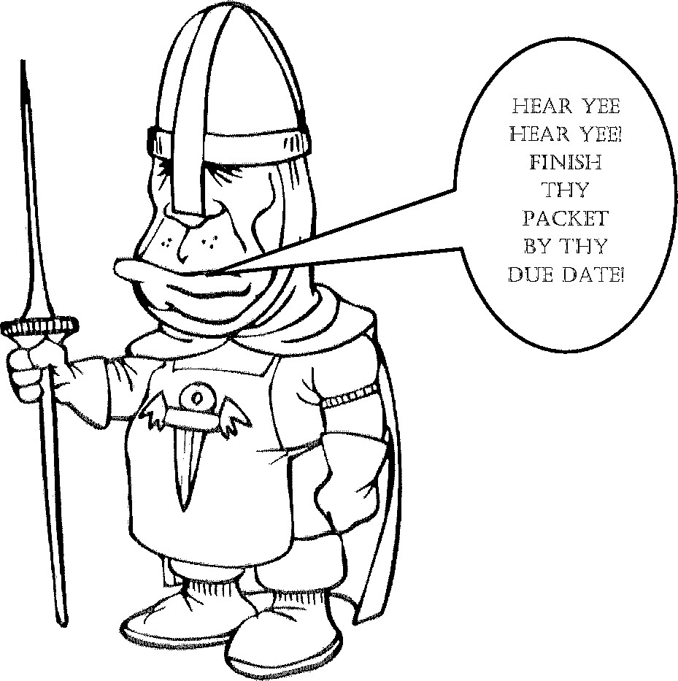
NAME: _____________________________________________________

TASK1DIRECTIONS:
Go to https://www.mapsofworld.com/europe/country-groupings/ and label and color the four regions of Europe on the map above. You may choose any colors you want but BE SURE each region is LABELED and has its own CO
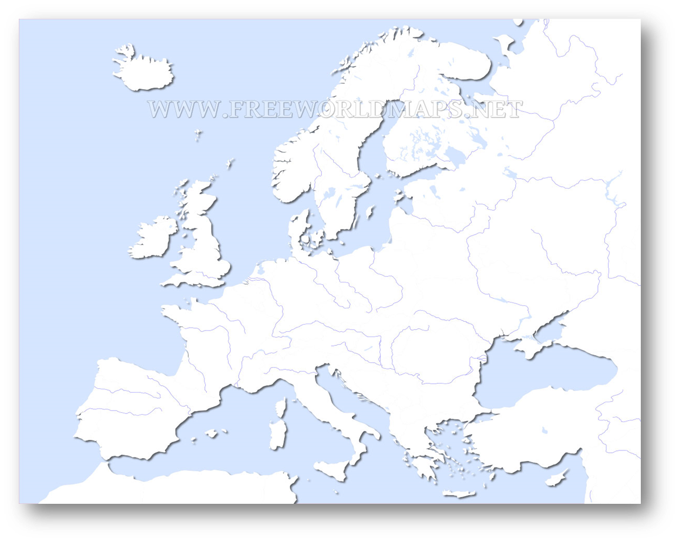

*People of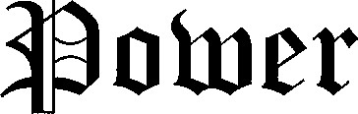

TASK 2 DIRECTIONS:

GO TO https://en.wikipedia.org/wiki/List_of_state_leaders_in_2017#Europe AND FIND OUT WHO THE CURRENT LEADERS OF EUROPEAN COUNTRIES ARE. THEN ANSWER THE TWO QUESTIONS AT THE BOTTOM.

- Norway
Monarch: _______________________________ Dates in Office:
Prime Minister: _______________________________ Dates in Office:

2. GERMANY
President: _______________________________ Dates in Office:
Chancellor: _______________________________ Dates in Office:

3. FRANCE
President: _______________________________ Dates in Office:
Chancellor: _______________________________ Dates in Office:
__________________________________________________________________
WHICH LEADER HAS BEEN IN POWER THE LONGEST?
______________________________________________________________

HOW MANY COUNTRIES IN EUROPE HAVE BOTH PRIME MINISTERS AND PRESIDENTS? __________________

TASK 3: Go to https://kids.britannica.com/kids/article/prime-minister/476305#intro and answer the following questions. Then complete the readings and THINK ABOUT IT questions.

- What is a Prime Minister? ________________________________________________________________________________________________________________________________________________________________________________________________
- How is a Prime Minister chosen?
________________________________________________________________________________________________________________________________________________________________________________________________

Read about the Government of France
“Over the years, France has been through many political crises. Its current government is a combination of presidential and parliamentary systems. The president is elected by the people and is head of state. A prime minister, chosen by the president, works with the elected parliament to pass laws.”

THINK ABOUT IT…..WHY DO YOU THINK FRANCE HAS BOTH A PRESIDENT AND A PRIME MINISTER?
_________________________________________________________________________________________________________________________________________________________________________________________________________________________________

Read about the government of the United Kingdom
“Britain's system of government has developed over many centuries. Kings once ruled with advice from a council of religious leaders and nobles. This council eventually expanded into the Parliament, which now passes all the country's laws. Today, the monarch (which can be a king or queen) has no real power.”
THINK ABOUT IT…..WHY DO YOU THINK THE UNITED KINGDOM STILL HAS A MONARCH (KING)?
_________________________________________________________________________________________________________________________________________________________________________________________________________________________________
Task 4:
Go to http://www.nationsonline.org/oneworld/european_languages.htm
and complete the table below, then answer the questions that follow.

Languages of Europe
There are dozens of languages spoken in Europe. However, most nations have an official language or one language that is spoken by most citizens. Identify the official or most common language or languages of each of the following European countries.

COUNTRY | OFFICIAL LANGUAGE(S) and NATIONAL LANGUAGES
Austria
Belgium
Finland
France
Germany
Greece
Italy
Lithuania
Norway
Poland
Portugal
Romania
Russia
Spain
Sweden
Switzerland
Ukraine
United Kingdom

1.Which language appears most often in your list? ________________________

2. List the countries in which this language is commonly spoken?
________________________________________________________________
3. In which regions of Europe are these countries located (HINT: look at your regions map in Task 1)?
________________________________________________________________

Use the internet to research and answer the last question:
- In ancient times, the Romans of the Italian Peninsula conquered most of the people of southern and western Europe. Their language, Latin, became the foundation for the Romance languages. Use the internet to find out what Romance languages are and list all the languages that are considered Romance languages.
________________________________________________________________________________________________________________________________________________________________________________________________________________________________________________________________________________________________________________________________________________________________________________________________

TASK 5:
Use PG. _________ of our World Atlas or the attached map to use the clues to help you locate the places described. Write the name of the location in the space provided.

- This Bay is west of France and north of Spain __________________________
- This country is east of Norway and west of Finland _____________________
- This island is south of Turkey __________________________
- This sea is east of the United Kingdom and southwest of Norway
_______________________________________

- This country is west of Spain __________________________________

- This sea is west of Estonia and Latvia and east of Sweden
__________________________________________________________

- This nation is west of Hungary and south of the Czech Republic.
_____________________________________________

- This nation is south of Romania and west of the Black Sea.
_______________________________________________

- This country is north of Italy and east of France ________________________

- This country is south of Macedonia ______________________________

- This body of water is between the United Kingdom and France
_________________________________________________

- This island country is west of Norway and northwest of the United Kingdom
____________________________________________

- List five countries that border Russia
____________________________________________________________________________________________________________________________

- List five countries that border the Mediterranean Sea
____________________________________________________________________________________________________________________________

