**The Geography of Algeria**

**Total Size:** 2,381,740 square km   
  
**Size Comparison:** slightly less than 3.5 times the size of Texas   
  
**Land:** mostly high plateau and desert; some mountains; coastal plain   
  
**Climate:** arid (dry); mild, wet winters with hot, dry summers along coast; drier with cold winters and hot summers on high plateau

Algeria is in northern Africa on the coast of the Mediterranean Sea. Its neighbors include Morocco and Tunisia to the north and Libya, Niger and Mali to the east and south. The Sahara Desert covers much of Algeria and most of the people live in the coastal plains near the Mediterranean Sea. Across the Mediterranean Sea lie Italy and Spain.

Algerian wildlife live close to cities and villages. The most commonly seen animals include the wild boars, jackals, and gazelles, although it is not uncommon to spot foxes, and jerboas. Algeria also has a few leopard and cheetah populations but these are seldom seen.

A variety of bird species make the country an attraction for bird watchers. Barbary macaques are the sole native monkey. Snakes, monitor lizards, and numerous other reptiles can be found living among an array of rodents throughout the desert regions of Algeria.

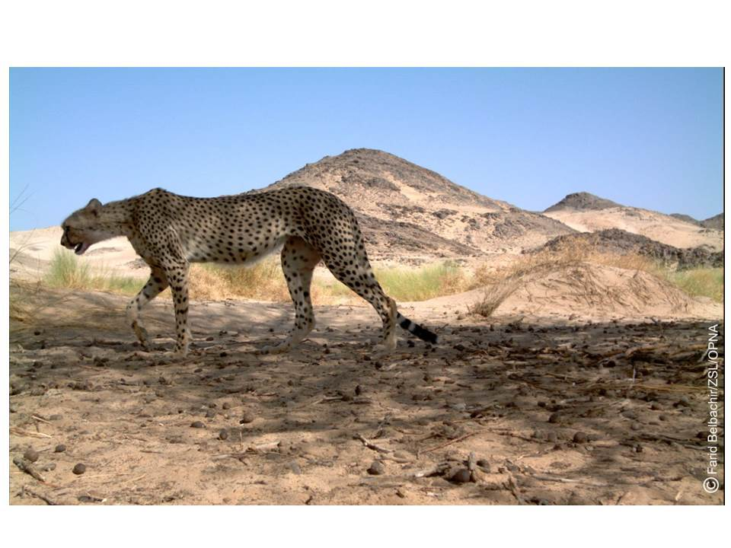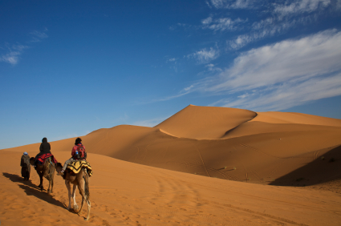

**The Geography of Democratic Republic of Congo**

**Total Size:** 2,345,410 square km   
  
**Size Comparison:** slightly less than one-fourth the size of the US   
  
**General Terrain:** vast rainforest; mountains in east   
  
**Climate:** tropical; hot and humid in equatorial river basin; cooler and drier in southern highlands; cooler and wetter in eastern highlands; north of Equator - wet season (April to October), dry season (December to February); south of Equator - wet season (November to March), dry season (April to October)

Near the Equator, the Democratic Republic of the Congo is the third largest country in Africa. The mighty Congo River flows north and then south through a land rich in minerals, fertile farmlands, and rain forests. The Congo rainforest is the second largest rainforest in the world after the Amazon.

Of course all of these trees, along with the rich variety of other plants here, provide a wonderful source of food for animals; including great apes like gorillas, chimpanzees and bonobos.

Other cool species found in this forest are the okapi (or forest giraffe) and the African forest elephant. (The forest elephant is smaller than its bush elephant cousins but has more toenails!) In fact, there are more animals per square kilometre in the Congo, than anywhere else in Africa.

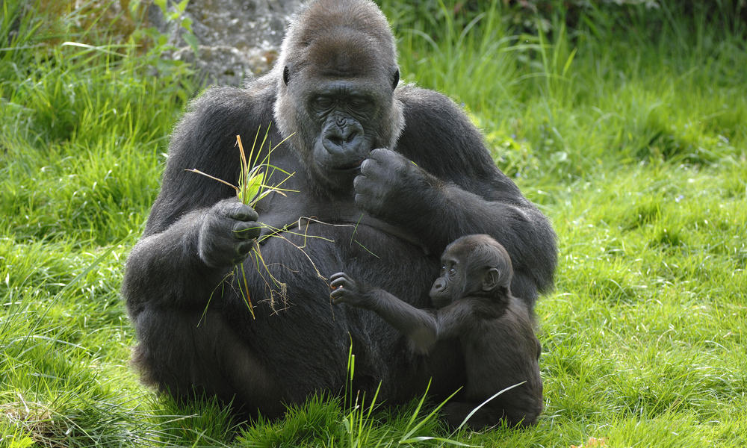 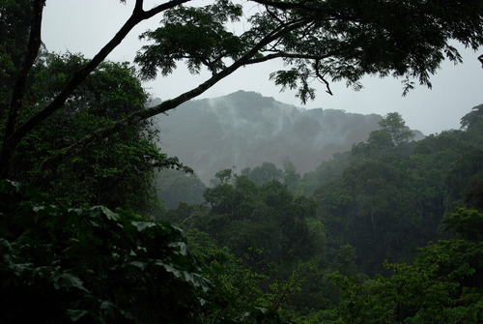

**The Geography of Egypt**

**Total Size:** 1,001,450 square km   
  
**Size Comparison:** slightly more than three times the size of New Mexico   
  
**General Terrain:** vast desert plateau interrupted by Nile valley and delta   
  
**Climate:** [desert](http://www.ducksters.com/science/ecosystems/desert_biome.php); hot, dry summers with moderate winters   
  
**Major Landforms:** Nile Delta (also known as Lower Egypt), Nile Valley (also known as Upper Egypt), Western (Libyan) Desert, Eastern Desert, Sinai Peninsula, Red Sea Hills, Great Sand Sea   
  
Without the Nile River, all of Egypt would be desert. Only about an inch (2.5 centimeters) of rain falls throughout Egypt each year. But each summer, the river rises because of rains at its source far to the south in Ethiopia. Floods cover the river's valleys, leaving sediments needed for trees, plants, and crops to grow.

Southern Egypt's landscape contains low mountains and desert. Northern Egypt has wide valleys near the Nile and desert to the east and west. North of Cairo, the capital, is the sprawling, triangular Nile River Delta. This fertile land is completely covered with farms.

Egypt is home to a wide variety of animals and plants, including jackals, gazelles, crocodiles, and cobras. The ancient Egyptians left paintings and carvings of large animals like elephants, hippos, leopards, and cheetahs. These animals were once common in Egypt, but they are now rare or extinct because of hunting and habitat loss.

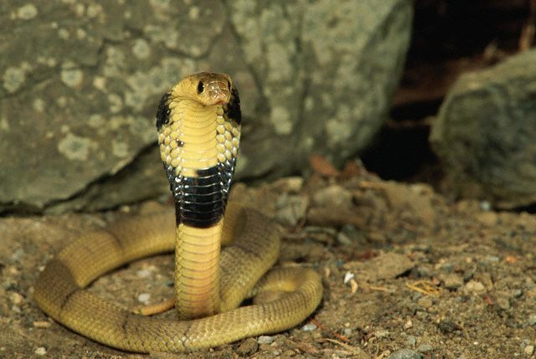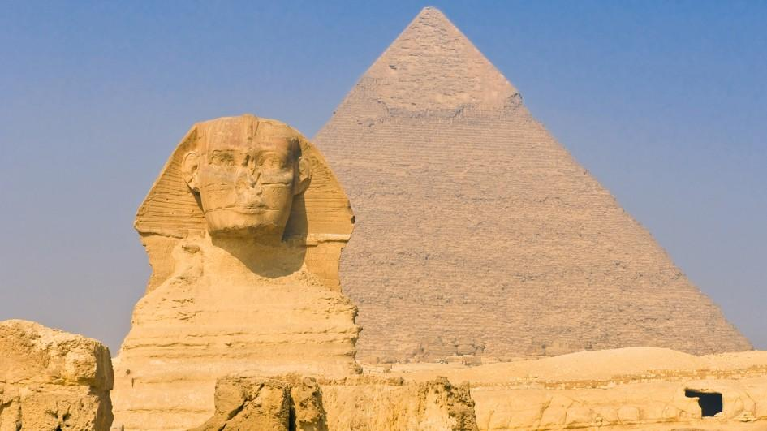

**The Geography of Kenya**

**Total Size:** 582,650 square km   
  
**Size Comparison:** slightly more than twice the size of Nevada   
  
**General Terrain:** low plains rise to central highlands (forested mountains) by Great Rift Valley; savannah (grasslands)    
  
**Climate:** varies from tropical along coast to arid (dry) in interior (middle   
  
Even if you've never been to Kenya, chances are you know what it looks like. Kenya's savanna is familiar from movies, TV shows, books, and commercials. It's the landscape many people imagine when they think of Africa.

Kenya is located in East Africa. Its terrain rises from a low coastal plain on the Indian Ocean to mountains and plateaus at its center. West of Nairobi the land descends to the Great Rift Valley, a 4,000-mile (6,400-kilometer) tear in the Earth's crust. Within this valley in the deserts of northern Kenya are the jade-green waters of famous Lake Turkana.

Millions of people visit Kenya each year to see its endless savanna and the animals that inhabit it: elephants, lions, cheetahs, giraffes, zebras, hippos, rhinos, and more. The Kenyan government has set up more than 50 reserves and parks to protect these animals. People seeking African wildlife usually focus on Kenya's lowland savannas. Kenya's highland forests are home to many animals found nowhere else in the world.

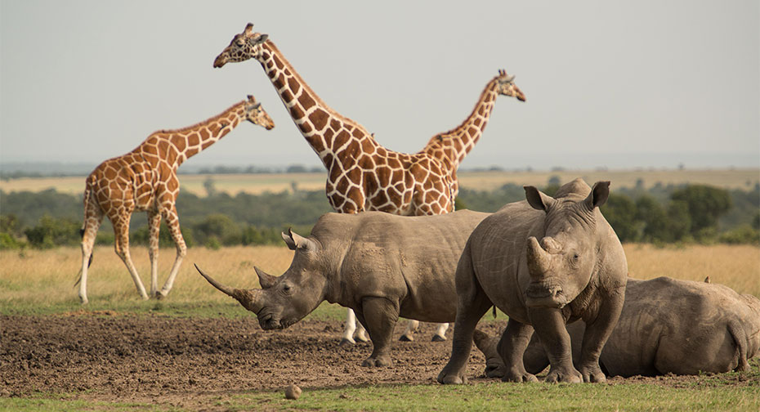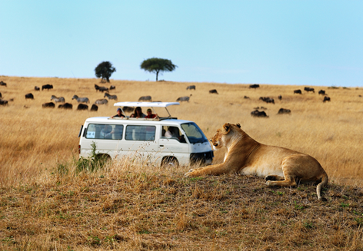

**The Geography of Madagascar**

**Total Size:** 587,040 square km   
  
**Size Comparison:** slightly less than twice the size of Arizona   
  
**General Terrain:** narrow coastal plain, high plateau and mountains in center   
  
**Climate:** tropical along coast, temperate inland, arid in south   
  
Off Africa's southeast coast in the Indian Ocean, Madagascar is the world's fourth largest island in the world. A stunning diversity of plant and animal species found nowhere else evolved after the island broke away from the African continent 165 million years ago. It has a mountainous central plateau and coastal plains.

Madagascar has two seasons: a hot, rainy season from November to April and a cooler, dry season from May to October. The east coast is the wettest part of the country and thus home to the island's rainforests. The central highlands are considerably cooler and drier, and are the location of much of Madagascar's farms. The west coast is home to dry deciduous forests. Deciduous trees lose all their leaves during the 6- to 8-month dry season.

Of roughly 200,000 known species found on Madagascar, about 150,000 are endemic -- meaning they exist nowhere else. Unique to the island are more than 50 types of lemurs, 99% of its frog species, and 36 types of birds. Madagascar houses 100% of the world's lemurs, half of its chameleon species, and 6% of its frogs.  The most famous carnivore found in Madagascar is the fossa, which was featured as a "bad guy" in the movie MADAGASCAR!. In reality, fossa aren't bad. Madagascar does not have apes, monkeys, elephants, zebras, giraffes, lions, hyenas, rhinos, antelopes, buffalo, camels, cats or dogs that you might expect to find in Africa.

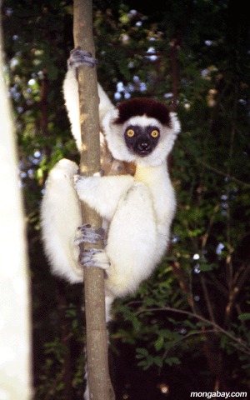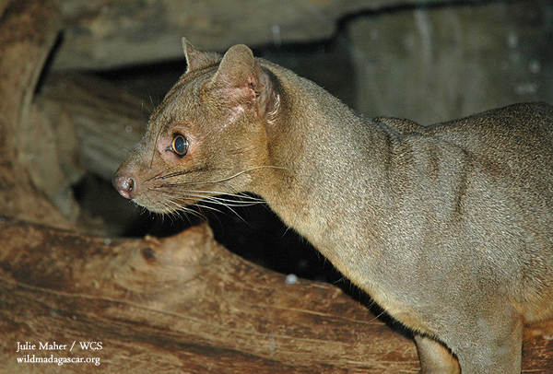

**The Geography of Equatorial Guinea**

**Total Size:** 28,051 square km   
  
**Size Comparison:** slightly smaller than Maryland   
  
**General Terrain:** coastal plains rise to interior hills; rainforest; islands are volcanic   
  
**Climate:** tropical; always hot, humid   
  
A small country on the west coast of central Africa, Equatorial Guinea comprises the mainland territory of Río Muni (where most people live) and five volcanic islands.

The coast of Río Muni, the continental portion of the country, consists of a long stretch of beach with low cliffs toward the south. A coastal plain about 12 miles (20 km) wide abuts the coastal hills, which lead to inland plateaus. The main island, Bioko, is about 45 miles (72 km) long and 22 miles (35 km) wide. Its extinct volcanic cones, crater lakes, and rich lava soils form a contrast with the landscape of the mainland. Bioko’s coast is largely inhospitable (people can’t live there).

Most of the country, including the islands, is tropical rain forest. On the volcanic islands it is difficult to farm but the rest of the country has tropical climate good for agriculture. Dense tropical rain forest vegetation prevails throughout Equatorial Guinea. There are 140 species of trees, especially palms and hardwoods. Yams and bananas were introduced by the early inhabitants and became staples. Monkeys, chimpanzees, elephants, and gray doves are common.

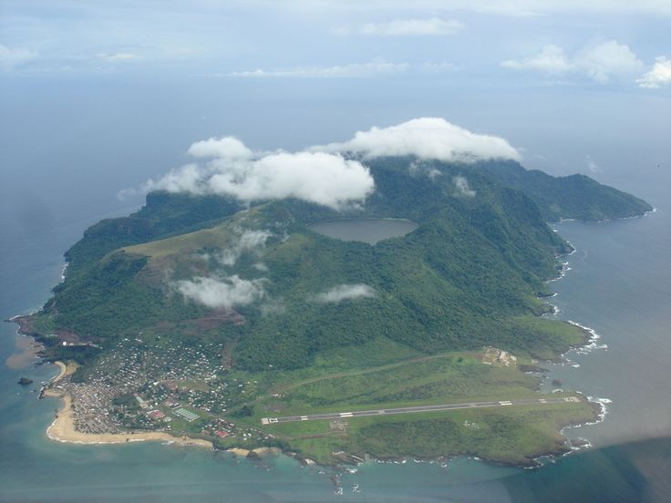

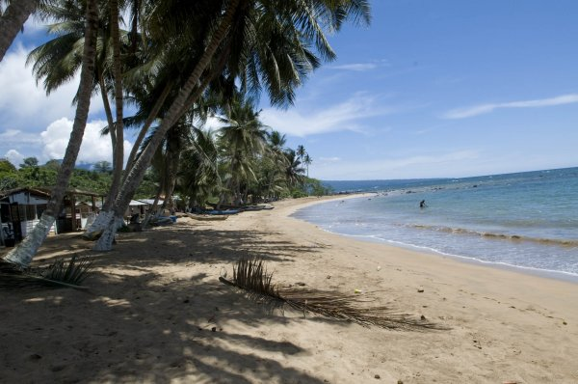 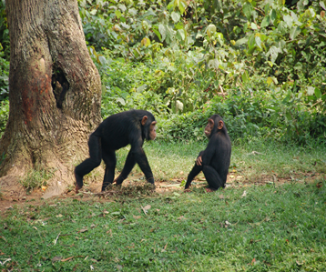

**The Geography of Somalia**

**Total Size:** 637,657 square km   
  
**Size Comparison:** slightly smaller than Texas   
  
**General Terrain:** mostly flat plateau rising to hills in north   
  
**Climate:** mostly desert; irregular rainfall, hot and humid periods (tangambili) between monsoons (rainy season)   
  
Somalia is a semiarid land in the Horn of Africa, and it is flat in the south, with mountains in the north reaching more than 6,500 feet. Somalia is a country of geographic extremes. The climate is mainly dry and hot, with landscapes of thornbush savanna (grasslands) and semi-desert. Apart from a mountainous coastal zone in the north and several pronounced river valleys, most of the country is extremely flat, with few natural barriers to restrict the mobility of the nomads (people who travel with their livestock.

Along with its large livestock herd, Somalia has one of the most abundant and varied stocks of wildlife in Africa. Animal life includes the elephant, lion, wildcat, giraffe, zebra, hyena, hippopotamus, waterbuck, gazelle, lizard, crocodile, turtle, porcupine, and boar. There is a large variety of snakes, the best known being the puff adder, the spitting cobra, and the krait. Domestic animals are camels, sheep, goats, and cattle. The most common birds are the ostrich, duck, guinea fowl, bustard, partridge, green pigeon, sand grouse, and heron.

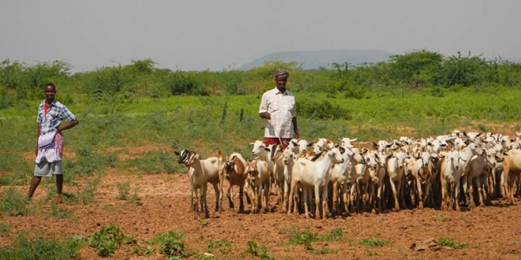 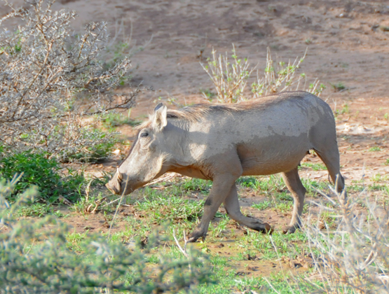

**The Geography of Swaziland**

**Total Size:** 17,363 square km   
  
**Size Comparison:** slightly smaller than New Jersey   
  
**General Terrain:** mostly mountains and hills; some moderately sloping grasslands and forests   
  
**Climate:** varies from tropical to near temperate   
  
Swaziland, consisting mostly of high plateaus and mountains, is in southern Africa. The natural vegetation includes forest, savanna, and grassland. There are both wet and dry forests and various savannah (grassland) types. Swaziland has more fresh water than most countries in southern Africa. Major rivers, which have their sources in South Africa, flow through the country to the Indian Ocean.

The wildlife has decreased because of the spread of the human population, and animals such as antelope, impala, reedbuck, waterbuck, wildebeest, hippopotamus, rhinoceros, elephant, giraffe, and zebra are found mostly in protected land reserves. However, smaller mammals—such as the baboon, monkey, jackal, and mongoose—may still be found in many place as well as, several types of snakes. Crocodiles are also common in rivers. Birdlife is abundant in Swaziland, the more common birds are barbets, weavers, the various hornbills, the lilac-breasted roller, and the purple-crested loerie.

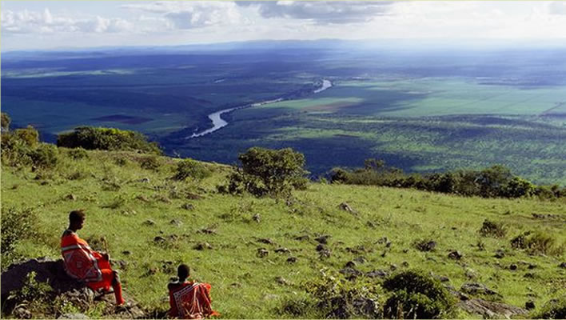 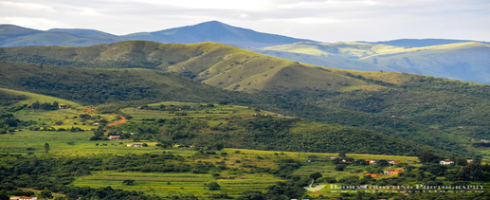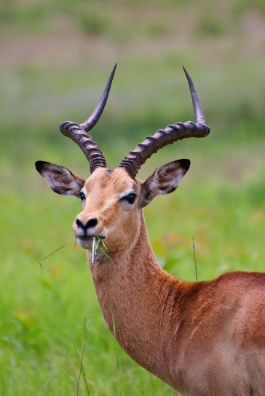

**The Geography of Sierra Leone**

**Total Size:** 71,740 square km   
  
**Size Comparison:** slightly smaller than South Carolina   
  
**General Terrain:** coastal belt of mangrove swamps, wooded hill country, upland plateau, mountains in east   
  
**Climate:** tropical; hot, humid; summer rainy season (May to December); winter dry season (December to April)   
  
Sierra Leone is a small country in West Africa, slightly larger than South Carolina. It sits along the Atlantic Ocean. A Portuguese explorer gave the country its name, which means “lion mountains” in 1462. Sierra Leone has miles of coastal plains, followed by muddy swamps. Further inland lie forests, jungles and farmlands. To the east is a mountain range.

Sierra Leone has 15 identified types of primates that include bushbaby, monkeys and a great ape, the common chimpanzee which is Sierra Leone's largest primate. Chimpanzees are found across the country with an estimated wild population in of 5500.

In the many waters of Sierra Leone there is a lot of wildlife. There are three species of crocodiles in Sierra Leone; the Nile crocodile, the slender-snouted crocodile which lives in forest streams, dwarf crocodile found in mangrove swamps. All the species of sea turtles live in the waters of Sierra Leone with the green turtle and leatherback turtle laying eggs on the shores of Turtle Island. Common species of lizard include the large Nile monitor, the agama seen around settlements, the Brook's house gecko often lives inside houses, and chameleons. There are several species of whales and the African manatee in the waters of Sierra Leone. The manatee is an endangered species and lives in the rivers and estuaries of Sierra Leone.

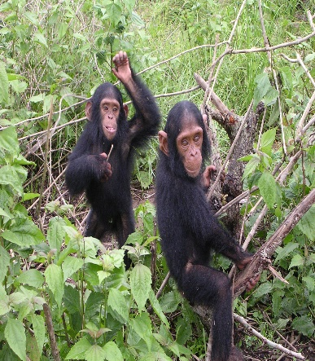 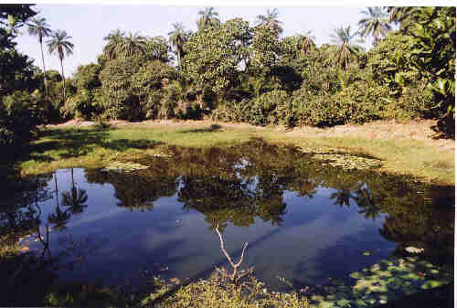 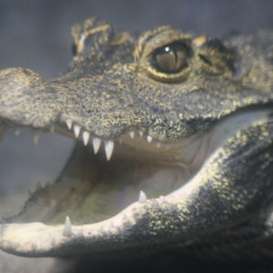

**The Geography of Uganda**

**Total Size:** 236,040 square km   
  
**Size Comparison:** slightly smaller than Oregon   
  
**General Terrain:** mostly plateau with rim of mountains   
  
**Geographical Low Point:** Lake Albert 621 m   
  
**Climate:** tropical; generally rainy with two dry seasons (December to February, June to August); semiarid in northeast   
  
Uganda is often called the *Pearl of Africa.* Uganda, twice the size of Pennsylvania, is in southeast Africa. It is bordered on the west by Congo, on the north by the Sudan, on the east by Kenya, and on the south by Tanzania and Rwanda. The country, which lies across the equator, is divided into three main areas—swampy lowlands, a fertile plateau with wooded hills, and a desert region. Lake Victoria forms part of the southern border.

Mountainous regions include the Rwenzori Mountains that run along the border with the Democratic Republic of Congo and an extinct volcano, Mount Elgon, sits along the border with Kenya. The capital city, Kampala, lies on the shores of Lake Victoria, the largest lake in Africa and second-largest freshwater inland body of water in the world.

Uganda is also home to more than half the world’s endangered mountain gorillas. Lion is quite common in Queen Elizabeth and Murchison Falls National Parks. Giraffe can only be found in Murchison Falls and Kidepo Valley national parks, while zebra exists only in Murchison Falls and Lake Mburo. Uganda is also great for birding watching with over 1000 different species.

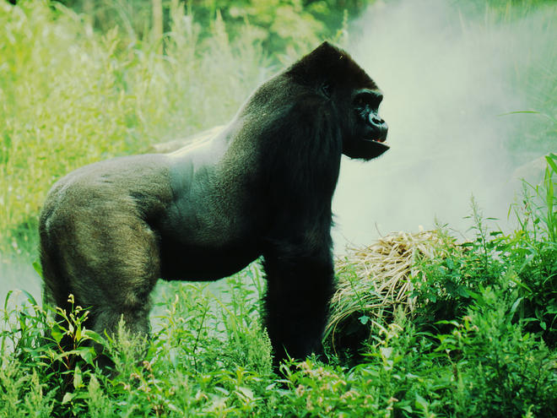 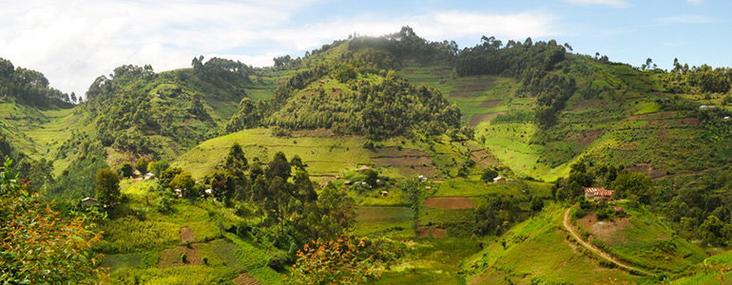 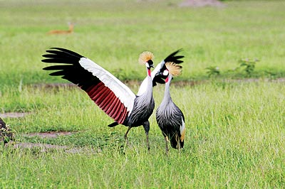

**The Geography of South Africa**

**Total Size:** 1,219,912 square km   
  
**Size Comparison:** slightly less than twice the size of Texas   
  
**General Terrain:** vast interior plateau rimmed by rugged hills and narrow coastal plain   
  
**Climate:** mostly semiarid; subtropical along east coast; sunny days, cool nights 

In South Africa, the Atlantic Ocean and the Indian Ocean meet off the Southern Cape coast. South Africa has various mountain ranges and the grasslands. In the middle of the country, you will find a high plateau.

The Kalahari Desert in the north is part of the highlands of the country. The longest river in South Africa is the Orange River. In the mountain ranges of the Drakensberg region, especially in the Lesotho Mountains, there is snow in winter and you even could go skiing in South Africa. Most of South Africa's landscape is made up of high, flat areas called plateaus.

From aardvarks to zebras, South Africa is full of wildlife. Wildlife in South Africa is abundant. There are many species of antelope such as kudu, springbok, wildebeest, impalas, oryx and gemsbok. When you go on safari you can see many other South African animals like lions, elephants, giraffes and monkeys. Many species are in danger of extinction, including the black rhinoceros, the cheetah, and the African wild dog.

The seas around South Africa are also crowded with wildlife. South Africa is home to the African Penguins and the Great White Sharks live in the ocean waters here too. Whale Watching is very popular in South Africa too and you will encounter an enormous sea life in South Africa when you go on a boat trip.

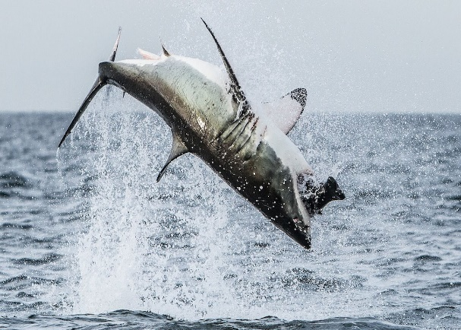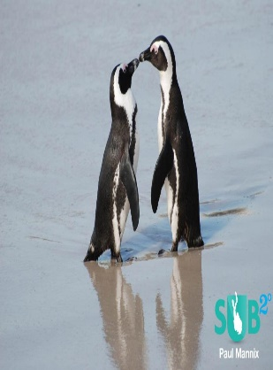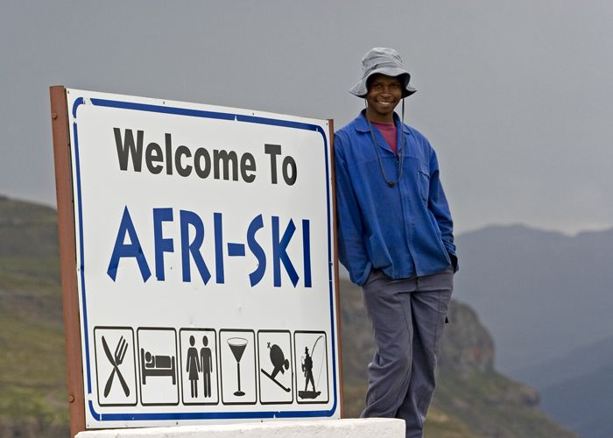

**The Geography of Mozambique**

**Total Size:** 801,590 square km   
  
**Size Comparison:** slightly less than twice the size of California   
  
**General Terrain:** mostly coastal lowlands, uplands in center, high plateaus in northwest, mountains in west   
  
**Climate:** tropical to subtropical

Mozambique stretches for 1,535 along Africa's southeast coast with many beaches bordered by lagoons, coral reefs and strings of small islands. The middle of the country is a grassland plateau which rises from the coast towards the mountains in the north and west covers nearly half the country's land area. It is nearly twice the size of California. The country is broken up by 25 sizable rivers that flow into the Indian Ocean. The largest is the Zambezi, which provides access to central Africa.

Tropical to sub-tropical Mozambican climate with coastal temperatures high for much of the year while the interior is warm to mild. In the south the hot, humid rainy season is from December to March. Coastal northern Mozambique climate is affected by tropical cyclones. It is usually sunny throughout the year.

Mozambique’s carnivores include spotted hyenas, leopards and lions. Among the most efficient large in Mozambique is the painted hunting dog. A number of monkey species roam Mozambique’s forests and savannas. Grasslands and open woodlands support species like chacma baboons and vervet monkeys. Blue monkeys inhabit thicker forests.

Mozambique’s reptiles range from sea turtles to Nile crocodiles and a few venomous snakes, including the black mamba, Gabon viper and Egyptian cobra. Other marine creatures include a variety of whales, dolphins, Cape fur seal; and numerous species of sharks, including the bull shark– biggest of all fish.

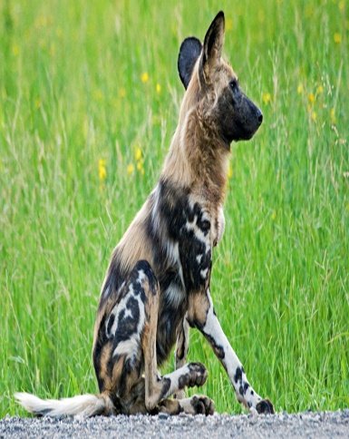 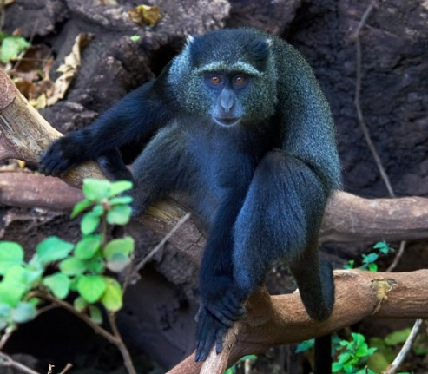 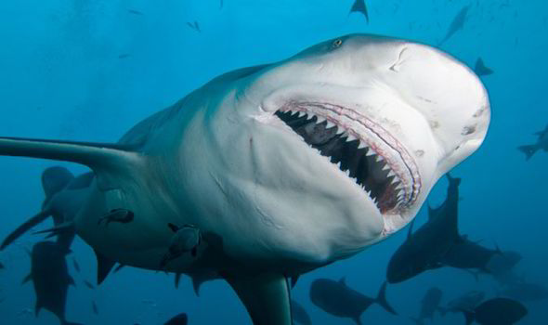

**The Geography of Botswana**

**Total Size:** 390,580 square km

**Size Comparison:** slightly larger than Montana

**Terrain:** mostly high plateau with higher central plateau (high veld); mountains in east

**Climate:** tropical; moderated by altitude; rainy season (November to March)

Botswana is a landlocked country in southern Africa. It is bordered by South Africa to the south and east, by Namibia to the west, and by Zimbabwe to the east. The country is smaller than the state of Texas.

The massive Kalahari Desert covers more than 70 percent of Botswana, spans about 360,000 square miles (900,000 square kilometers), and touches nine African countries. The Kalahari isn't a true desert because it gets more rainfall each year than most deserts receive. Because drought is a problem in Botswana, rain is precious. When rain comes, it's sporadic and often causes flooding.

Most of the country is covered by grassland called savanna. The most common tree is the baobab tree and some baobabs are 2,000 years old. The Okavango Delta and Chobe National Park in the north are areas of outstanding natural beauty and rich in animal life.

Elephants at Chobe are the largest in body size of all living elephants; they number more than 50,000.Meerkats are also common in the country. Populations of cheetahs and lions continue to decrease due to factors including hunting and farmers protecting their livestock.

About 17 percent of Botswana has been set aside for game preserves and national parks. Tourists from all over the globe visit Botswana for safaris and a chance to see amazing wildebeests, giraffes, jackals, hyenas, lions, cheetahs, and other animal species.

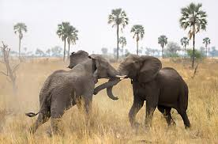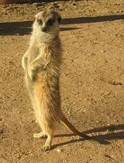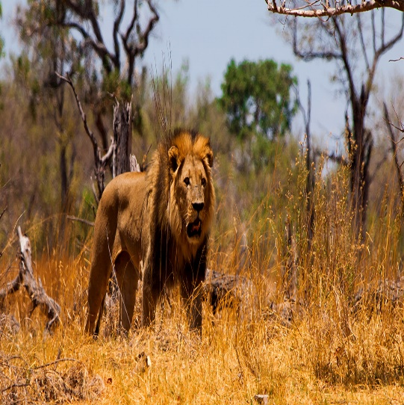

**The Geography of Namibia**

**Total Size:** 825,418 square km

**Size Comparison:** slightly more than half the size of Alaska

**Terrain:** mostly high plateau; Namib Desert along coast; Kalahari Desert in east

**Climate:** desert; hot, dry; rainfall sparse and erratic

Namibia is the most sparsely population country in the world with only 2 people per square mile. Namibia is a vast country with many dry regions. The Namib Desert stretches along the Atlantic ocean over with huge sand dunes as far as the eye can see. This desert is considered the oldest desert in the world and also has some of the highest dunes in the world. The Kalahari Desert stretches along the eastern border of the country and is varied in vegetation. Some parts are very dry and desert-like whereas others have more grassland and mountainous and rocky regions. Many farmers raise livestock because the land isn't suitable for crops.

Namibia's climate is typical of a semi-desert and high plateau country, with hot days and cool nights.

Namibia has a variety of venomous snakes, scorpions, and spiders, but bites or stings from these are rare. The plains and the dunes of the Inner Namib support large numbers of several varieties of antelope, especially gemsbok (oryx) and springbok, as well as ostriches and some zebras. Elephants, rhinoceroses, lions, hyenas, and jackals are found in the northern Namib, especially along the rivers that flow from the interior highlands to the Atlantic. The dunes of the Outer Namib provide habitats for various types of insects and reptiles, especially beetles, geckos, and snakes, but virtually no mammals. The shore area is densely populated by marine birds—notably flamingos, pelicans, and, in the southern part, penguins

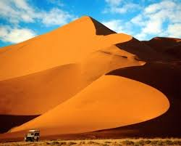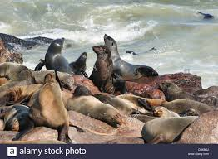



**The Geography of Ghana**

**Total Size:** 239,460 square km

**Size Comparison:** slightly smaller than Oregon

**Terrain:** mostly low plains with dissected plateau in south-central area

**Climate:** tropical; warm and comparatively dry along southeast coast; hot and humid in southwest; hot and dry in north

In the northern reaches of the country, the Tibesti Mountains dominate the landscape of the surrounding Sahara Desert. It receives very little rain, and most of the vegetation is a savanna growth of sparse grasses and shrubs. The central region of Chad mostly consists of flat semi-arid land and savannah. In the south, the forested land is nourished by the Chari and Logone Rivers. During the monsoon rains, Lake Chad often overflows, causing floods in the lowland depression of the south.

The climate of Chad varys. The north is hot and arid, receiving almost no rain. It is known as the ‘Saharan zone’. The central region is hot and subtropical, with a wet season from May to November which normally brings over 350mm of rain and in some places much more.In the south, rainfall is higher and on average, regions receive over 1,000mm.

Across the north, east and central arid or semi-arid areas, farmers rely on grazing livestock across wide areas. Cattle are the most prized animals, but in the driest areas, nomadic groups often raise hardier animals such as goats and camels. Many areas of Chad would once have had dense woodlands and an abundance of wildlife. However, in the past century many trees have been cut down and soils have become drier. Wildlife numbers have been severely affected by loss of natural habitat. Hunting and competition from livestock have also led to the virtual elimination of large animal species, such as lions, leopards and rhino. Smaller mammals, such as rodent species, are still common, as are reptiles such as crocodiles, rock pythons and spitting cobras.

