Name: ______________________________ Grade: _______
Age of Exploration
1. Why did Europeans begin to explore west?
______________________________________________________________________________
______________________________________________________________________________
______________________________________________________________________________
2. In the table below explain how each invention improved travel by sea.
Astrolabe  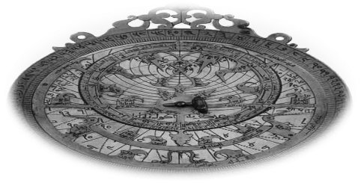 |  | Compass  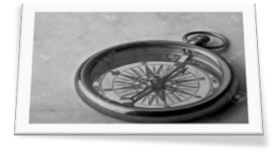
Better Maps  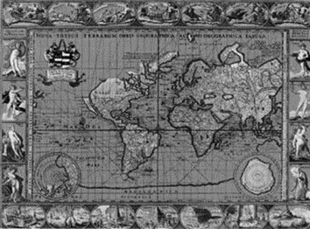 |  | Better Ships  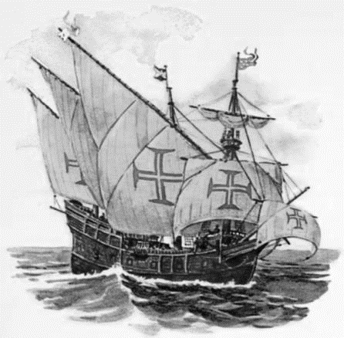

Directions: Read pg. 25-27 “New Horizons” and answer the questions below.
2. Explain two long-term effects of the Crusades.
______________________________________________________________________________________________________________________________________________________________________________________________________________________________________________________________________________
3. What was the Renaissance?
____________________________________________________________________________________________________________________________________________________________________________________
4. What nations became powerful during the Renaissance?
____________________________________________________________________________________________________________________________________________________________________________________

5. What was the Reformation?
____________________________________________________________________________________________________________________________________________________________________________________

6. What affect did the Reformation have on the people of Europe?
____________________________________________________________________________________________________________________________________________________________________________________

7. How might these events have made people more likely to explore other lands?
________________________________________________________________________________________________________________________________________________________________________________________________________________________________________________________________________________________________________________________________________________________________________

8. How might Europeans of that time benefit from increased trade?
____________________________________________________________________________________________________________________________________________________________________________________

