Name: ________________________________________________________
Physical Map of Europe
Directions: Label all locations and follow the coloring instructions below.
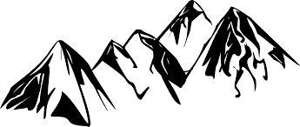
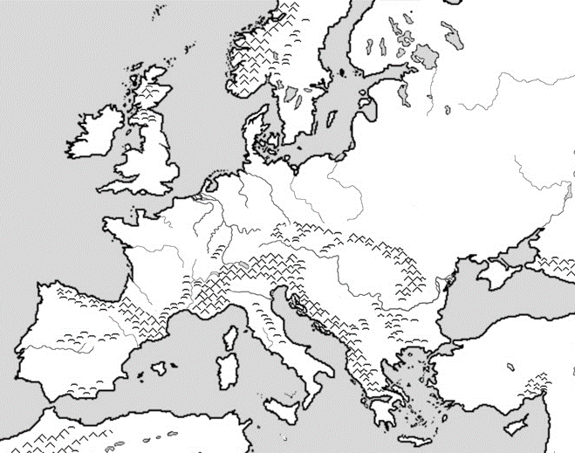
Label and Color BLUE
Danube River
Rhine River
English Channel
Mediterranean Sea

Label and Color BROWN
the Alps
Pyrenees
Ural Mountains

Label and Color RED
Iberian Peninsula

Label and Color YELLOW
Scandinavian Peninsula

Label and Color GREEN
European Plain

Directions: While exploring the video tour, answer the following questions.
Rhine: Where is it located? _______________________________________
Location Countries to Choose from:
Russia Greece
Spain Norway
Switzerland Germany
France Austria
Italy Finland
- Since ancient times, the Rhine has been one of the world’s __________________________rivers.
- Why are there so many castles along the Rhine River?
________________________________________________________________________________
________________________________________________________________________________
Alps: Where are they located? _____________________________________________________________
- What modes of transportation do people use to visit the Alps?
_______________________________________________________________________________
- How is life in Grimmelwald unique? __________________________________________________
________________________________________________________________________________
- The most famous peak in the Alps is the _______________________________________________
Pyrenees: Where are they located? _______________________________________________________
- Why is crossing the Pyrenees difficult? ________________________________________________
__________________________________________________________________________________________________________________
Fjords: Where are they located? _____________________________________________________
- What is a fjord? _____________________________________________________________________________________________________
Urals: Where are they located? ___________________________________________________________________________
- The Urals are the world’s __________________________ mountains
Mediterranean Sea: Where is it located? ____________________________________________________________________
- There are as many as ________________________________ship wrecks on the bottom of the Mediterranean Sea.

