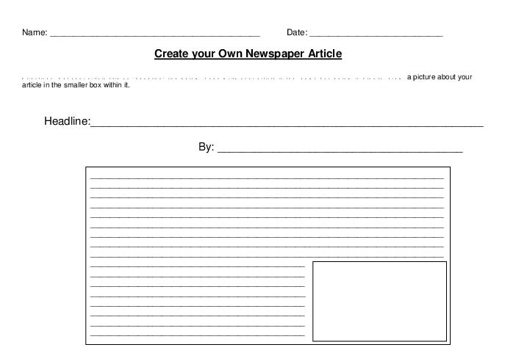



Published on (date) ___________________________________________