Africa’s Climate and Resources
Climate of Africa A places location in relation to the equator affects the seasons. North of the Equator, winter and summer occur at the same time as in the United States. South of the Equator, the seasons are reversed, with winter Beginning in June.
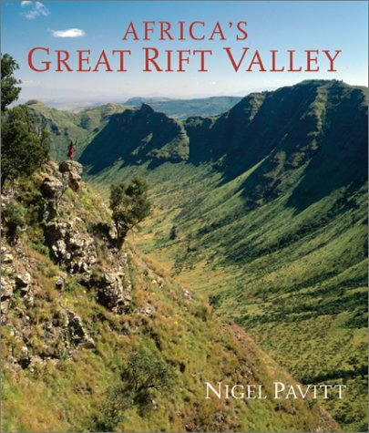
Elevation, or height above sea level, also affects climate. The higher the elevation, the cooler a place tends to be. The countries of Ethiopia and Somalia are about the same distance from the Equator, but have different climates. Ethiopia is on a very high plateau and has mild temperatures and a lot of rain. Farmers grow many crops—including bananas, coffee, dates, and oaks. Somalia, is at a lower elevation. It is hot and dry so farming is only possible near rivers.

Adapting to the Land
The land in Africa’s different regions is so different people have to adapt to the seasons and to the land in order to make a living.
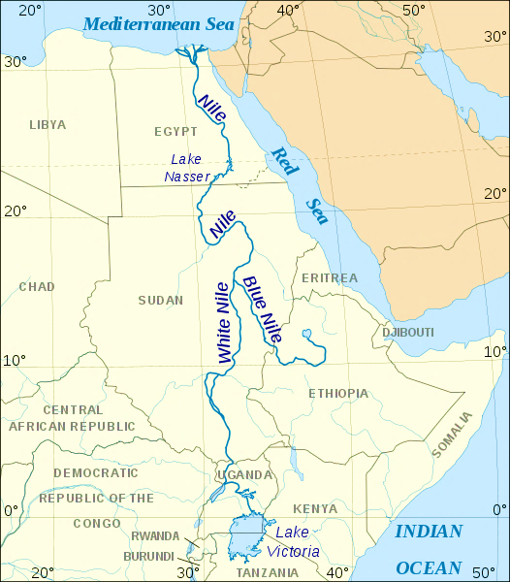
Tropical Rain Forest
Tropical rain forests are regions where it rains nearly all the time. The moisture allows for many different kinds of plants and animals. Throughout the year, people who live near rain forest cut trees for wood or to clear land for farming.
Tropical Savannahs
Much of Africa north and south of the rain forest is tropical savannah. The savanna is a region of tall grasses. During the dry season, farming is impossible but in the wet season the land turns green and farmers plant their crops.

Deserts in Africa
Beyond the savanna lie the deserts. In the south lie the Kalahari and the Namib deserts. In the North is the vast Sahara desert. Nomads, people who move to different places to make a living, and traders live in the deserts. Many herd animals and travel to where they can get food and water for their camels, goats, and sheep. Others transport goods from place to place to make a living.

Agricultural Resources
Most of Africa’s workers are farmers. Many are subsistence farmers. Subsistence farmers raise crops to support their families. They have little or nothing left to sell or trade. In northern Africa, farmers raise barley and wheat. In the dry tropical savannas, subsistence farmers grow grains. In regions with more rainfall, farmers grow vegetables and fruits.

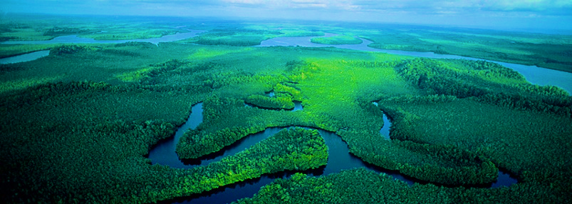

Cash Crops
In all regions of Africa, farmers raise crops to sell called cash crops. In West Africa, famers grow cash crops of coffee and cacao. Farmers in East Africa, grow tea. As more land is used for cash crops, less land is planted with crops to feed families. In some regions, this has led to food shortages when cash crops fail to grow or sell.

Minerals and Energy Resources
Mining is also important to Africa’s economy, system of producing, distributing, consuming, and owning goods, services, and wealth. In North Africa, there are larges amounts of petroleum which is used to make oil and gasoline. In parts of West and South Africa, gold is a major source of wealth. In fact, the country of Ghana in West Africa was once called the Gold Coast. Other resources in Africa include copper, silver, uranium, and diamonds. Although South Africa is famous for its diamond mines, diamonds are found in many places in Africa.
Mining requires many workers and costly equipment. Throughout much of Africa, foreign companies min African resources and take the profits. This system does little to help Africa’s economy.

