***Directions: Use the graphic on pg. 40 to fill in the organizer below.***

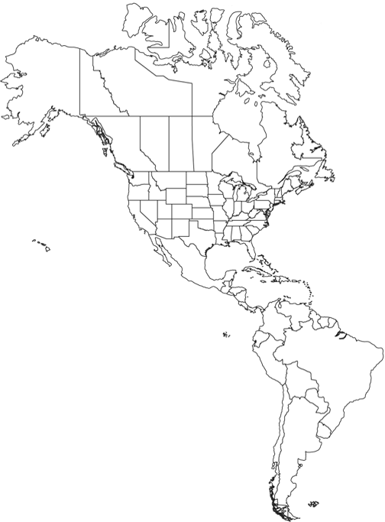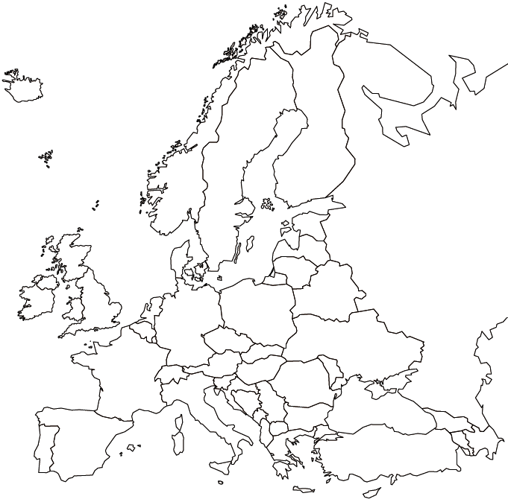

**The Columbian Exchange**

**:**

**Items that moved from the Americas to Europe**

**Items that moved from Europe to the Americas**