Names: ________________________________ ______________________________________
Diversity of Africa: Partner Activity Research Guide
Directions: Using the Atlas map of Africa on pg. _______ to shade in your country on the blank map below.
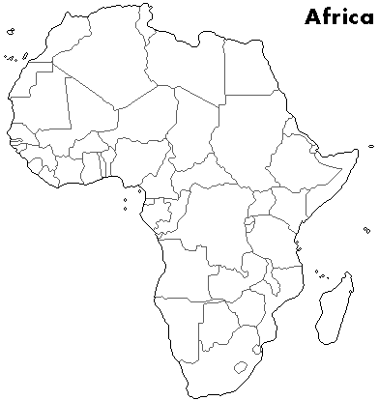
Name of your country:
_______________________________
Directions: Using information from your article describe your country in the table below.
Size  - How big is it?  - How big is it compared to the United States? | Land  - What would you expect the land to look like if you visited?  - How does the land look different in regions of your country? | Wildlife  - What animals/plants would you expect to see there?
Directions: Write 3 questions you have about your country.
“I wonder….”
1. ____________________________________________________________________________
2. ____________________________________________________________________________
3. ____________________________________________________________________________

Directions: Using the internet, research your country and find out some interesting facts about your country.
1. ____________________________________________________________________________
______________________________________________________________________________
2. ____________________________________________________________________________
_____________________________________________________________________________
3. ___________________________________________________________________________
_____________________________________________________________________________
4. ___________________________________________________________________________
_____________________________________________________________________________
5. ___________________________________________________________________________
_____________________________________________________________________________
6. ___________________________________________________________________________
_____________________________________________________________________________
7. ___________________________________________________________________________
____________________________________________________________________________
8. __________________________________________________________________________
____________________________________________________________________________
9. __________________________________________________________________________
____________________________________________________________________________
10. _________________________________________________________________________
____________________________________________________________________________

Name: _________________________________________

DIVERSITY: the state of having many unique, different characteristics. A place is diverse when it has lots of different landforms, climates, wildlife, and cultures of people.
After the presentations you will be asked to explain how Africa is diverse. You will have to use at least two different countries in Africa to answer the question. In your answer, you will have to compare the land and wildlife of the two countries and explain how this shows the geographic diversity of Africa. To help you do this you will want to take notes about the countries your classmates present. Be sure to write down the name of the country
Diversity of Africa Presentation Notes:
____________________________________________________________________________________________________________________________________________________________
____________________________________________________________________________________________________________________________________________________________
____________________________________________________________________________________________________________________________________________________________
____________________________________________________________________________________________________________________________________________________________
____________________________________________________________________________________________________________________________________________________________
____________________________________________________________________________________________________________________________________________________________
____________________________________________________________________________________________________________________________________________________________

Directions: Using your presentation notes answer the question below.
How is Africa diverse? Use two different countries to explain how the land and animals are very diverse in different countries in Africa.

Africa is very diverse because _____________________________________________________
_____________________________________________________________________________.
Two examples of how Africa is very diverse is the countries of _______________________ and
__________________________________.

The land of these two countries is very different.
In _______________________________, the land is __________________________________
_____________________________________________________________________________.
In ______________________________, the land is ___________________________________
_____________________________________________________________________________.

The wildlife if these two countries is also very different.
In _____________________________, the wildlife ____________________________________
_____________________________________________________________________________.
In ____________________________, the wildlife _____________________________________
_____________________________________________________________________________.

As you can see _______________________________ and ______________________________ are very different countries. Africa is very diverse because ______________________________
______________________________________________________________________________

