Diwali - 23 October 2014

Festival of Lights
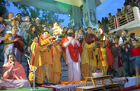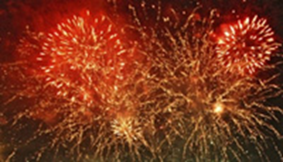
Diwali is perhaps the most well-known of the Hindu festivals.
The word Diwali means 'rows of lighted lamps'. Diwali is known as the 'festival of lights' because houses, shops and public places are decorated with small earthenware oil lamps called diyas.

Celebrating Diwali
For many Indians this five day festival honors Lakshmi, the goddess of wealth.
People start the new business year at Diwali, and some Hindus will say prayers to the goddess for a successful year.
Lamps are lit to help Lakshmi, the goddess of wealth, find her way into people's homes.
They also celebrate one of the Diwali legends, which tells of the return of Rama and Sita to Rama's kingdom after fourteen years of exile.
In Britain, as in India, the festival is a time for:
- spring-cleaning the home,
- wearing new clothes
- exchanging gifts (often sweets and dried fruits) and preparing festive meals
- decorating buildings with fancy lights.
- huge firework displays often celebrate Diwali.
In India Hindus will leave the windows and doors of their houses open so that Lakshmi will come in. Rangoli patterns decorate their homes and temples during festivals. Rangoli is created to welcome visitors (both gods and people) in.

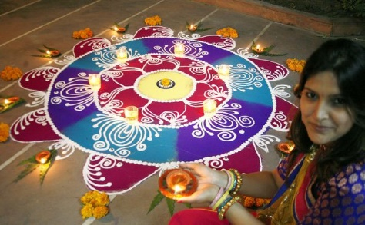

The meaning of Diwali
The festival celebrates the victory of good over evil, light over darkness and knowledge over ignorance, although the actual legends that go with the festival are different in different parts of India:
- In northern India and elsewhere, Diwali celebrates Rama's return from fourteen years of exile to Ayodhya after the defeat of Ravana and his subsequent coronation as king;
- In Gujarat, the festival honours Lakshmi, the goddess of wealth;
- In Nepal Diwali commemorates the victory of Lord Krishna over the demon king Narakaasura;
- In Bengal, it is associated with the goddess Kali.

Names: ______________________________
Diwali Questions:
1. What does Diwali mean? ____________________________________________
2. How long does Diwali last? __________________________________________
3. What goddess is celebrated on Diwali? _____________________________
4. Why are lamps lit on Diwali?
____________________________________________________________________________________
5. List 3 ways Diwali is celebrated.
_______________________________________________
_______________________________________________
_______________________________________________

6. After watching the video, write a three sentence summary of the story of Rama and Sita.
____________________________________________________________________________________________________________________________________________________________________________________________________________________________________________________________________________________________________________________________________________________________________________________________________________________________________

