Source A: Crash Course Video

https://www.youtube.com/watch?v=6QJ09TGy9kc

Source B: What was left behind?
Toys: The Indus Valley people made many toys, games, and small figures of people and animals, using metal and clay. | 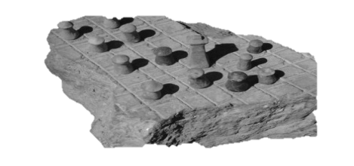

Writing: What can we learn about the writing that was left behind? Well, not very much. No one knows what language the Indus people spoke, and no one has yet been able to read their writing.

Seals: Seals like this were found in streets or outside buildings. They were thought to have been used by merchants as a way of trade. This was perhaps a way for the owner to be sure that their products could not be sold by anyone else.
Tools: Most of the metal items made were tools, very few weapons were found. | 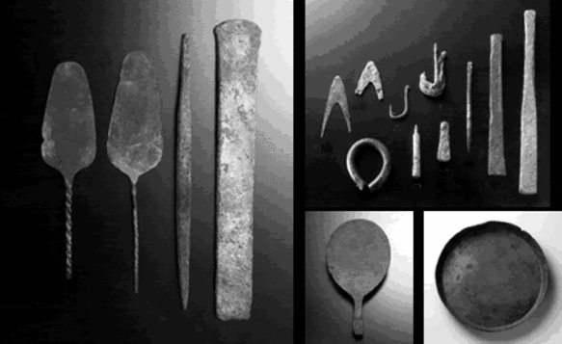
Jewelry: Lots of finely made jewelry was found made with metal, beads, and shells. | 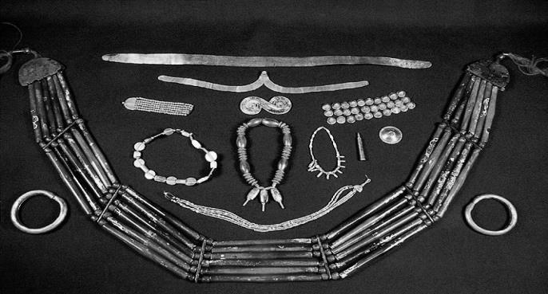

Source C: Examine the artifact evidence at the following website and record observations and inferences on investigation guide

http://www.bbc.co.uk/guides/zcsbr82#z834kqt

Source D: Investigate with Professor Indus at the following website and answer questions along the way

http://www.bbc.co.uk/schools/primaryhistory/indus_valley/the_end_of_the_indus/

Source E: Read sections on website and answer questions

http://www.bbc.co.uk/schools/primaryhistory/indus_valley/the_end_of_the_indus/

What happened to the Indus Valley cities?

The Indus cities were at their richest between 2600 and 1900 BC. Between 1900 and 1700 BC, this great civilisation started to fall apart.

Trade with Mesopotamia stopped. Archaeological evidence shows how things got worse. The Great Bath at Mohenjo-Daro was built over. The city mounds got overcrowded. Drains blocked up. Some traders even hid their valuables under the floors of their houses! People stopped repairing old homes. Why did this happen?

Was there a war?
Hindu poems called the Rig Veda (about 1500 BC) describe northern invaders conquering the Indus Valley cities. In the 1940s, archaeologist Mortimer Wheeler (1890- 1976) discovered 39 human skeletons at Mohenjo-Daro. He believed that they were people killed by invaders.
Archaeologists now think this is not true. There is no evidence of war or mass killings. Indus Valley people seem to have been peaceful. If they had an army, they have left few signs of weapons or battles.
It's more likely that the cities collapsed after natural disasters. Enemies might have moved in afterwards.

Floods, famine and disease?
What caused the peaceful, rich and organized Indus civilisation to collapse? Perhaps a river changed course, causing floods in some areas, and droughts (lack of water) in other places. There might have been an earthquake.
If there was an environmentalal disaster cities would have flooded and food crops would have failed. People would have starved and diseases spread. Evidence from skeletons shows that many people died from malaria, a disease spread by mosquitoes.
Perhaps the rulers lost control of their cities. Trade stopped and workshops closed. Drains, streets and houses crumbled.

Source F: Read and describe current theories about the disappearance of the Harappan civilization. Then compare with your groups theory.
- Watch video when done at 6:51 minutes https://www.youtube.com/watch?v=n7ndRwqJYDM&feature=youtu.be&t=412

What happened to the Indus River Valley Civilization?

The Indus Valley Civilization began to decline around 1800 BCE. There are several theories to explain the disappearance of the Indus Valley Civilization, including the Aryan Invasion and climate change.
The Aryan Invasion Theory (ca. 1800 - 1500 BC)
One theory suggests that a nomadic (travelling group) of people called the Aryans conquered the Indus Valley Civilization. Using horses and more advanced weapons against the peaceful Indus Valley people, the Aryans may have easily defeated the native peoples of northern India. However, many elements of the Indus Civilization are found in later cultures, suggesting the civilization did not disappear suddenly.
The Climate Change Theory (ca. 1800 - 1500 BC)
Today, many scholars now believe that the fall of the Indus Valley Civilization was caused by climate change as the monsoons (seasonal winds that brought rain) migrated (moved) east. Because the people relied on the rain, the water supply dried up as the monsoons moved eastward. The Indus Valley Civilization residents may have migrated towards the Ganges River in the east, where they established smaller villages and farms. These communities could not produce the same amount of food to support large cities.
Natural disasters, such as droughts, floods, and changes in the course of the Indus River may have also caused the fall of the Indus Valley Civilization. Around 1800 BCE, the Indus valley climate grew cooler and drier and movement of the Earth’s plates may have caused the river to move. By around 1700 BCE, most of the Indus Valley Civilization cities had been abandoned.

Source G: BBC Video
- Watch BBC video clip on Harappan decline from “The Story of India” (15:00-25:00; 10 minutes) https://www.youtube.com/watch?v=M5Ipx2T7VlQ

