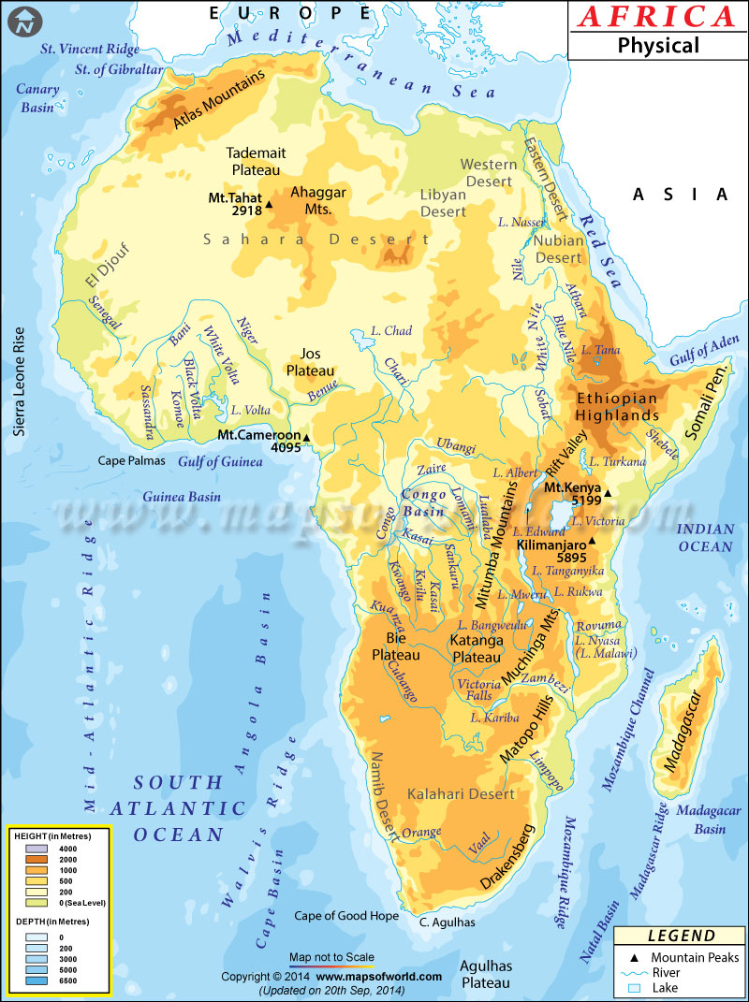

Name: _______________________________________________________
Climate Map of Africa
Directions: Follow the coloring guide below to identify the following climates of Africa.
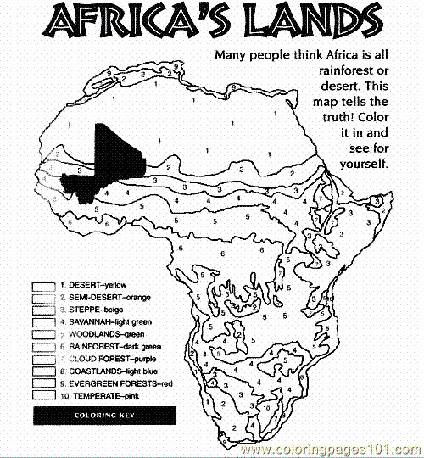
Directions: Read and follow the directions below to complete the physical map of Africa
Label: to write the name in the correct location neatly
Color: lightly shade with a crayon or colored pencil so you can still see the writing
LABEL/COLOR BLUE LABEL/COLOR BROWN LABEL/ COLOR YELLOW
Atlantic Ocean Sahara Desert Atlas Mountains
Indian Ocean Kalahari Desert Mt. Kilamanjaro
Mediterranean Sea Namib Desert Mt. Kenya
Red Sea Nubian Desert Mt. Tahat
Nile River Ethiopian Highlands
Niger River LABEL/COLOR GREEN Katanga Plateau
Zambezi River Congo Basin Rift Valley
Lake Victoria Cape of Good Hope

Name: _____________________________________________

Physical Map of Africa
