Name: ______________________________________ Grade: ___________

Map Skills Activity
I. Purpose:
1. Brainstorm with a partner: When have you used a map and what did it help you do?

2. Write down where you think each map is showing and what purpose the map could have.
 | Where? | What can it help you do? | Did you  get it right?
Map #1
Map #2
Map #3
Map #4
Map #5

I. Direction:
3. Label the Compass Rose with the directions with the abbreviations N, S, E, W, NE, SE, NW, SW
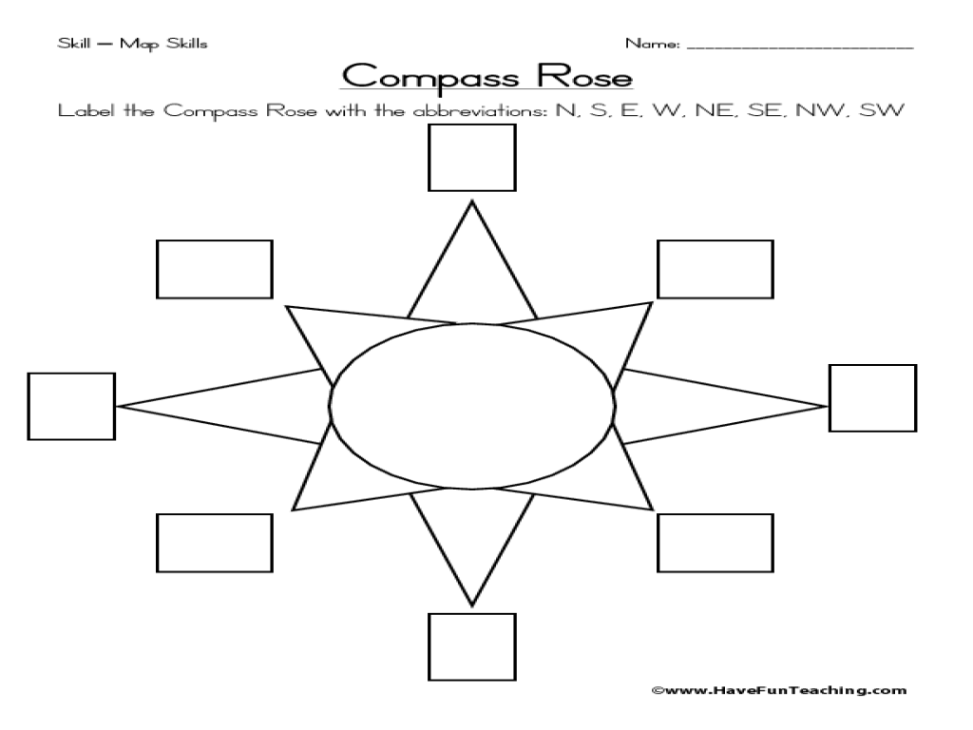
4. If the whiteboard is north, give the direction of each item in our classroom.
Classroom Values Board ________
Mrs. White’s desk ________
Art Supplies closet ________
Lockers/Textbooks ________
Door ________
Make-up Work ________

5. Partner Practice with Map Directions: Get the stick man to the following locations by writing the directions and number of steps (squares) in which to travel.
Where | Number of Steps | Direction
Start Church Raft Train | 1, 3, 2 | North, East, North
Start School Bus
Start House Train
Airplane Raft
School Bus Church

6. Use the map of eastern Kentucky and the compass rose to indicate which direction you would travel to go from one town to another (N, E, W, S, NE, SE, NW, SW).
Prestonsburg to Paintsville ______________
Morehead to Greenup ______________
Hazard to Salyersville ______________
Pikeville to Elkhorn City ______________
Jackson to Morehead ______________

II. Symbols & Colors:
7. What do you think each symbol means?
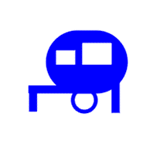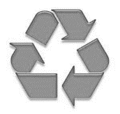
_____________ _____________ _____________ _____________ _____________

8. With your table partner: Study the two maps of Kentucky and answer the questions below.
a. What symbols are on Map 1? __________________________________________________
b. What symbols are on Map 2? __________________________________________________
c. Which map do you think is more useful? Why? ____________________________________________________________________________
____________________________________________________________________________
9. With your table partner study the map of Kentucky below and do the 5 steps. 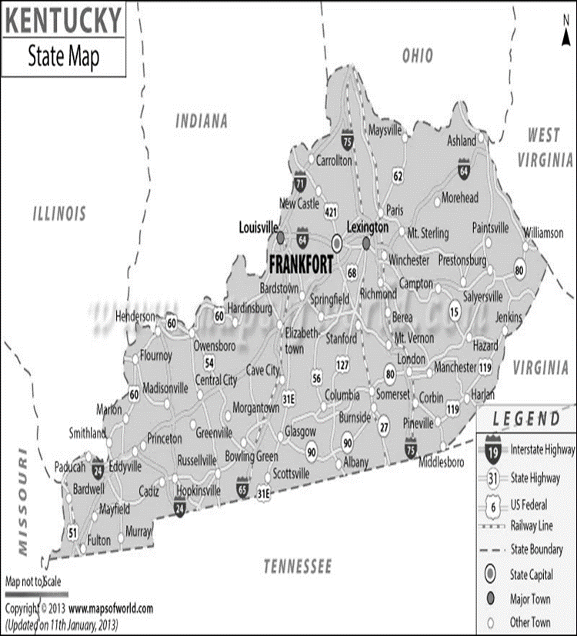

Step 1: Circle the capital

Step 2: Underline the 2 major “towns”

Step 3: Trace the border between Kentucky and West Virginia

Step 4: List 2 interstate highways _______________ ________________

Step 5: List 2 state highways _______________ ________________
10. Below draw a map of our classroom. Use symbols to show where classroom items are located (desks, door, windows, boards, shelves, furniture, lockers, etc.). Fill in the map key explaining what each symbol stands for. Be sure to include a compass rose and map title!

Map Key/Legend:
III. Scale:
