News Articles for Location Activity
Amatrice, Italy:
Directions:
1. Pass out Atlases and coordinates to students
2. Have them use atlases pgs _____________ to determine their location
3. Have ask teacher for articles
4. Complete article activity
5. Share with Class

Latitude: 42°N
Longitude: 13° E
Paris, France:
Latitude:48° N
Longitude: 2°E
Rio Janeiro, Brazil:
Latitude: 23°S
Longitude: 43°W
Los Angeles, California:
Latitude: 34°N
Longitude: 118°W
Baxter State Park, Maine:
Latitude: 46°N
Longitude: 69°W

Latitude: 42°N  Longitude: 13° E | Latitude: 42°N  Longitude: 13° E
Latitude:48° N  Longitude: 2°E | Latitude:48° N  Longitude: 2°E
Latitude: 23°S  Longitude: 43°W | Latitude: 23°S  Longitude: 43°W
Latitude: 34°N  Longitude: 118°W | Latitude: 34°N  Longitude: 118°W
Latitude: 46°N  Longitude: 69°W | Latitude: 46°N  Longitude: 69°W

Earthquake Hits Central in Amatrice, Italy August 24, 2016
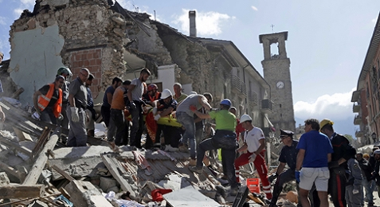
After a powerful earthquake in central Italy, rescuers carry an injured person on a stretcher.
A 6.2 magnitude earthquake struck the Apennine regions of central Italy on Wednesday August 24th. At least 120 people have been confirmed as dead, and around 150 people are feared missing.
Amatrice, a small town of about 2,600, was worst hit by the quake. Early Wednesday, residents gathered in the town center to await word of survivors. Others stood among the rubble of their former homes. They looked out for aid workers coming to bring them food and basic supplies. While earthquakes are common in this region, the latest quake to hit the country was a particularly bad one. Here’s what we know about it:
When and where did the earthquake occur?
A 6.2 magnitude quake hit at 3.36 a.m. A second quake, of 5.4 magnitude, followed at 4.33 a.m. The worst-hit towns are believed to be Accumoli, Amatrice, Posta and Arquata del Tronto. But even residents in Rome, some 105 miles away were awakened by the quake. It rattled furniture and swayed lights in most of central Italy. Italy’s Civil Protection agency has described the earthquake as “severe.” Lina Mercantini told reporters that the earthquake “was so strong” that it “seemed the bed was walking across the room by itself with us on it
How did the buildings hold up?
Not well. “Half the town is gone,” the Mayor told reporters. “There are people under the rubble. There’s been a landslide and a bridge might collapse,” he added. The hospital in the mountain town also had to be evacuated due to structural damage. While the hospital was declared non-operational, none of the patients were reported injured. In the meantime, the Mayor of Amatrice, Italy has made 250 temporary homes that were built after a 2009 earthquake available for the newly displaced.

A Historic Flood in Paris, France June 08, 2016
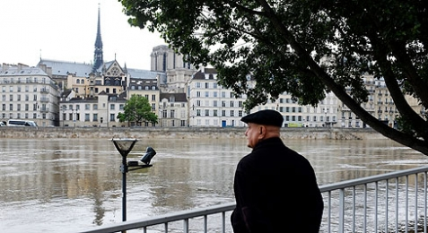
A man looks at the flooding Seine River in Paris, France, on June 3. The river swelled to 15 feet above average levels because of heavy rains.
On Wednesday, June 8, art lovers around the world breathed a sigh of relief. The Louvre, a famous art museum in Paris, France, reopened its doors after closing for days due to historic flooding that threatened to damage the museum’s precious works of art. More than 9 million people visit the museum each year.
Last week, heavy rains across parts of Europe caused the Seine River, in Paris, France, to rise to its highest level since 1982. The widespread flooding forced the Louvre to temporarily close to the public on Friday, June 3, to allow museum workers to move thousands of paintings and sculptures to higher ground. According to a statement from the museum, closing for four days cost the Louvre about $1.7 million in ticket sales.
The Louvre is right next to the Seine River. At the peak of the flooding, the river swelled to more than 15 feet above its average levels. At first, the museum announced that its underground storage spaces were secure enough to protect the collection from water damage. But the museum changed their mind once the Seine began bursting its banks. Over the weekend, workers moved 35,000 works from storage areas and low-lying galleries.
Widespread Damage
While flooding has decreased thanks to a break in the rain, parts of France, Germany, and Belgium are still recovering. On Wednesday, June 8, France’s Cabinet declared a “natural disaster” in 782 towns and villages hardest hit by the rains. In total, 20,000 people have been temporarily evacuated from their homes, and at least 19 people have been killed. The Seine’s water levels peaked on June 4, but have been steadily falling. French Prime Minister Manuel Valls said the river’s levels are decreasing “slowly but steadily.”

Games Over in Rio de Janeiro Brazil August 22, 2016
Brazilian dancers perform during the closing ceremony of the 2016 Summer Olympics in Rio de Janeiro.
The 2016 Olympics ended in spectacular fashion Sunday night, with a three-hour closing ceremony in Rio de Janeiro, Brazil. Athletes from 206 countries, plus a team of refugees, proudly carried their national flags through the Olympic stadium. Simone Biles, a gymnast who made history by winning five Olympic medals in the 2016 Games, including four gold medals, held the American flag. The festivities also celebrated Brazilian culture, with a colorful Carnival-themed parade and fireworks.
At the end of the celebration, Brazil officially passed the Summer Olympic hosting duties on to Japan. The 2020 Games will be held in Tokyo, Japan. That country’s prime minister, Shinzo Abe, made a particularly fun appearance. He appeared on the stage out of a huge green pipe dressed as the video-game character Super Mario. The performance was a nod to Nintendo, a popular Japanese video game company.
In the finally tally, the U.S. achieved a commanding victory in the medal count. U.S. athletes took home a combined 121 medals, including 46 gold medals. The second-place finisher was China, whose athletes won 70 total medals, including 26 gold.
Packed Final Days
The last weekend of the Rio Olympics was full of exciting moments and big events. On Saturday, the heavily favored U.S. women’s basketball team won its gold-medal match against Spain, 101–72. The U.S. also won the gold in the men’s 1,500-meter race. Matthew Centrowitz came in first place, winning that event for the U.S. for the first time since 1908. On Sunday, the U.S. men’s basketball team was also victorious. It won the U.S.’s third-straight basketball gold medal in a match against Serbia.
The final event of the Rio Olympics was the men’s marathon, a 26.2-mile race. Eliud Kipchoge of Kenya won the gold. That meant Kenya won both Olympic marathons; Jemima Sumgong became the first Kenyan to get the gold medal in the women’s race on August 14. Feyisa Lilesa of Ethiopia took the silver medal in the men’s event, and U.S. runner Galen Rupp won bronze.

Wildfires Blaze near Los Angeles, California

August 17, 2016
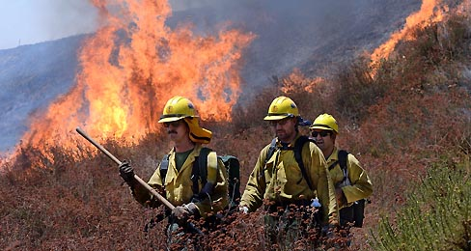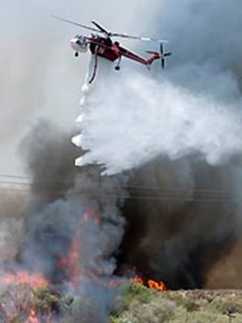
Firefighters battle a major blaze in California, on August 16.
It started as a small blaze Tuesday morning, on the side of Interstate 15, near Los Angeles, California. But by the end of the day, the Southern California wildfire had swallowed up 47 square miles, forced tens of thousands of people to evacuate, and destroyed dozens of buildings. The fire has thoroughly disrupted life in the area, blocking roadways, causing hours-long traffic jams, and sending panicked residents fleeing from their homes.
The blaze moved quickly on its first day. “It went from ‘have you heard there’s a fire?’ to ‘mandatory evacuation’ before you could take it all in,” Darren Dalton, 51, who lives in the evacuation area, told the Associated Press. California governor Jerry Brown declared a state of emergency within hours of the start of the fire. That measure usually comes much later, after a fire has caused destruction over several days.
Local authorities ordered the evacuation of 34,000 homes and 82,000 people. When one family failed to cooperate, firefighters were called to protect their home. Six of them were briefly trapped by the blaze. “We just hunkered down and sat there and waited for the fire to blow over,” firefighter Cody Anderson says.
Multiple Blazes
The Southern California fire wasn’t the only one burning in the state. The Clayton fire, in Northern California, had destroyed more than 175 buildings as of August 15. That fire is 40% contained and some evacuated residents have been able to return to their homes. But firefighters will have to continue to battle the blaze, which is still threatening hundreds of structures.
Meanwhile, the Chimney Fire, which began August 13 in San Luis Obispo County, California, is about 25% contained. It has destroyed 40 buildings and burned more than 7,300 acres.
Wednesday’s weather is expected to make fighting the Southern California fire difficult. Hot, dry conditions and wind will likely work against firefighters’ efforts.

New National Monument in Northern Maine August 26, 2016
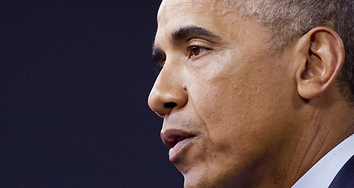
President Barack Obama has announced that he will establish a new national monument in Maine. He will also expand a monument off the coast of Hawaii, creating the world’s largest marine protected area.
As the National Park Service celebrates its 100th anniversary, President Barack Obama has announced the creation of one new national monument. In Maine, more than 87,500 acres of forest will become government-protected parkland for the first time.
.Obama has now created or enlarged 26 national monuments during his presidency. As a result, his administration says, Obama has protected more of the nation’s land than any other president has. But some residents and officials, in both Maine and Hawaii, object to the plans. They say their local economies depend on the use of these areas.
The Maine Woods
From now on, a vast stretch of rugged woods in Northern Maine will be known as the Katahdin Woods and Waters National Monument. This area of mountains, dense forest, and raging rivers will be much larger than the 48,900-acre Acadia National Park on Maine’s coast.
In establishing this monument, Obama took the side of conservationists who want laws to protect wild lands. Creating a national park usually requires the approval of Congress. But a 1906 federal law, known as the Antiquities Act, allows the president to establish national monuments on his own.
The land’s new status as a monument means that new mining and drilling operations are banned there. It may also severely limit activities such as logging, road-building, grazing, and hunting. Some of Maine’s politicians who want to protect the state’s lumber and logging industries say Obama should not have acted alone. They say Washington should not tell the states how to use their land, especially when people’s jobs are at stake. Maine senator Susan Collins said the president should have listened to Maine lawmakers and residents, as well as to the U.S. Congress, before making his decision.

Names: __________________________________________________

World News Article Partner Practice
Step 1 Directions: Use your World Atlas and the latitude and longitude coordinates you were given to figure out what location you will be reading news about. Write the coordinates and location below.
Amatrice, Italy Paris, France Rio Janeiro, Brazil
Los Angeles, California Baxter State Park, Maine

Latitude __________ Longitude __________
Location ___________________________________________

Step 2 Directions: Write a five sentence summary of your news article. Some questions you should answer in your summary: What happened? Why did it happen? When did it happen? What affect did it have?

____________________________________________________________________________________________________________________________________________________________________________________________________________________________________________________________________________________________________________________________________________________________________________________________________________________________________________________________________________________________________________________________________________________________________________________________________________

