Part 1: Africa’s Physical Geography
Africa can be divided into four regions; 1. North, 2. West, 3. East, and 4. Central and Southern. Each region contains many different climates and physical features.
North Africa is marked by rocky mountains and the world’s largest desert, the Sahara. The Sahara is almost the size of the United States! West Africa, has the most people. It consists mostly of grasslands. The soil in the grasslands is good for farming.
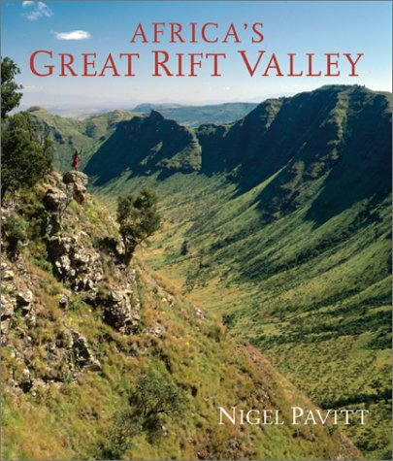
East Africa contains many mountains and plateaus, large high areas of flat land. The East also has areas of grasslands and hills. The Great Rift Valley is also in East Africa. The Great Rift Valley was formed millions of years ago, when the continents pulled apart. A rift is a deep trench that cuts through the Earth. The Great Rift Valley is 4,000 miles long and most of Africa’s major lakes are located in or near the Great Rift. The East region also has the tallest mountain, Mt. Kilimanjaro.

Much of Central and Southern Africa is flat or rolling grasslands. The Namib Desert of the country of Namibia and the Kalahari Desert of Botswana are also in this region. Along much of Africa’s coast is a strip of coastal plain. This strip is dry and sandy in some places and swampy in others.
The Rivers of Africa
Four large rivers carry water from the mountains of Africa’s plateaus to the sea. They are the Nile, the Congo, the Niger, and the Zambezi. The rivers are useful for travel but they are broken in places by cataracts, or rock-filled rapids that make it difficult to travel or transport goods from one region to another.
The Nile River
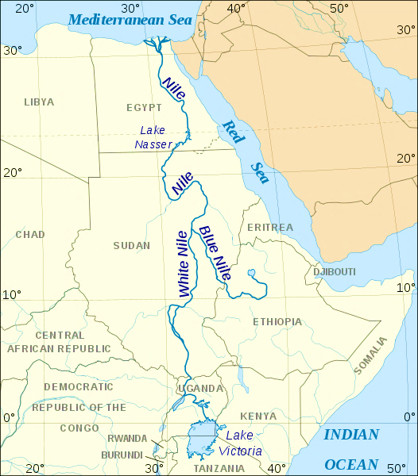
The Nile is the longest river in the world. Its length, more than 4,000 miles is more than the width of the United States. The river flows north from Uganda (White Nile) and Ethopia (Blue Nile) into the Mediterranean Sea. People have farmed the land around the Nile for thousands of years, all the way back to the ancient Egyptians. At one time, the Nile flooded at the same time every year, leaving behind rich, fertile soil made of tiny pieces of rock and soil called silt. This silt had substances that plants need in order to grow well.

The Congo River
The Congo River flows through the rain forest of the country of Congo in Central Africa. At 2,720 miles long, the Congo is Africa’s second longest river. People in this region grow grains and catch fist in the Congo with basket traps.

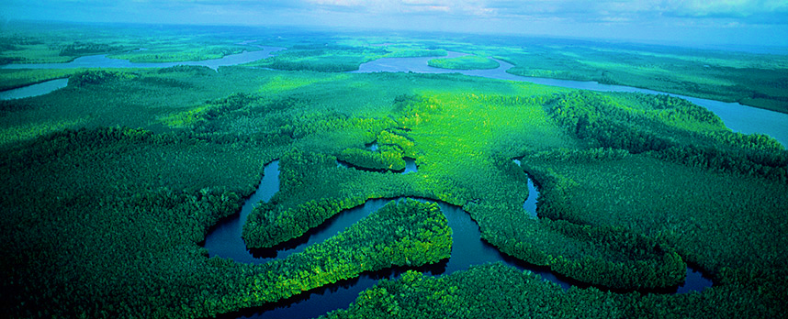

The Niger River
Africa’s third largest river, the Niger River, begins in Equatorial Guinea. It provides water for farms in the river valley and many people make a living fishing in the river.
The Zambezi River
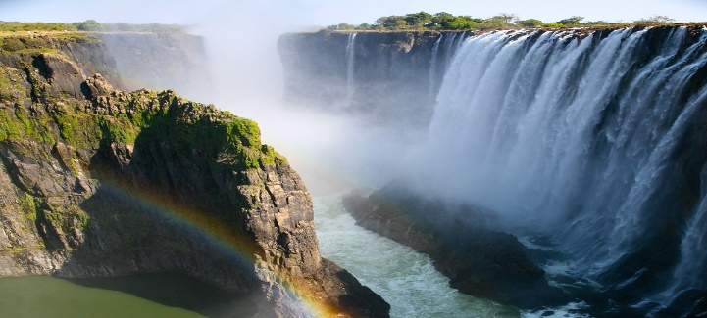
The fourth-longest river in Africa, the Zambezi River, is in Southern Africa. It runs through the countries of Angola, Zambia, Namibia, Zimbabwe, and Mozambique. People use the river’s strong current to make electricity. About halfway to its outlet into the Indian Ocean the Zambezi plunges into a canyon, creating Victoria Falls. The African name for Victoria Falls is “the smoke that thunders”. People can see the mist and spray from 40 miles away.

Africa is Diverse
Africa is a giant. More than three times bigger than the United States. It covers more than 11,700,000 square miles, about one-fifth of all the land in the world. Traveling north-to-south, a trip across the African continent would take about 77 hours, or 3 days and five hours; no wonder if took bush pilot Tom Claytor 2 years to explore Africa! Africa is often called a “plateau continent” because the elevation, the height of the land above sea level, is very high and all four regions of Africa contain mountains. Since Africa is so big, it is also so diverse—with many different climates, landforms, and animals.
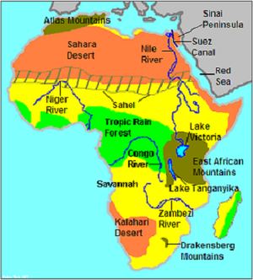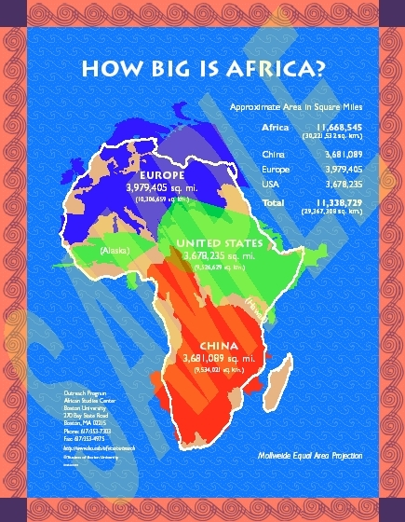

Part 2: Africa’s Climate and Resources
Climate of Africa A places location in relation to the equator affects the seasons. North of the Equator, winter and summer occur at the same time as in the United States. South of the Equator, the seasons are reversed, with winter Beginning in June.
Elevation, or height above sea level, also affects climate. The higher the elevation, the cooler a place tends to be. The countries of Ethiopia and Somalia are about the same distance from the Equator, but have different climates. Ethiopia is on a very high plateau and has mild temperatures and a lot of rain. Farmers grow many crops—including bananas, coffee, dates, and oaks. Somalia, is at a lower elevation. It is hot and dry so farming is only possible near rivers.

Adapting to the Land
The land in Africa’s different regions is so different people have to adapt to the seasons and to the land in order to make a living.
Tropical Rain Forest
Tropical rain forests are regions where it rains nearly all the time. The moisture allows for many different kinds of plants and animals. Throughout the year, people who live near rain forest cut trees for wood or to clear land for farming.
Tropical Savannahs
Much of Africa north and south of the rain forest is tropical savannah. The savanna is a region of tall grasses. During the dry season, farming is impossible but in the wet season the land turns green and farmers plant their crops.

Deserts in Africa
Beyond the savanna lie the deserts. In the south lie the Kalahari and the Namib deserts. In the North is the vast Sahara desert. Nomads, people who move to different places to make a living, and traders live in the deserts. Many herd animals and travel to where they can get food and water for their camels, goats, and sheep. Others transport goods from place to place to make a living.

Agricultural Resources
Most of Africa’s workers are farmers. Many are subsistence farmers. Subsistence farmers raise crops to support their families. They have little or nothing left to sell or trade. In northern Africa, farmers raise barley and wheat. In the dry tropical savannas, subsistence farmers grow grains. In regions with more rainfall, farmers grow vegetables and fruits.

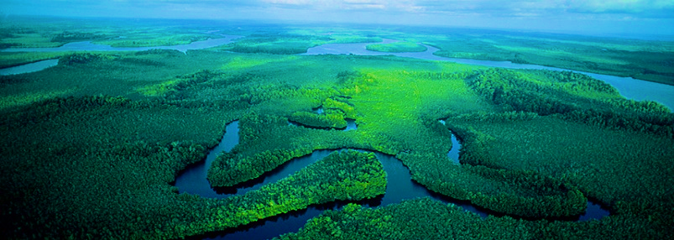

Cash Crops
In all regions of Africa, farmers raise crops to sell called cash crops. In West Africa, famers grow cash crops of coffee and cacao. Farmers in East Africa, grow tea. As more land is used for cash crops, less land is planted with crops to feed families. In some regions, this has led to food shortages when cash crops fail to grow or sell.

Minerals and Energy Resources
Mining is also important to Africa’s economy, system of producing, distributing, consuming, and owning goods, services, and wealth. In North Africa, there are larges amounts of petroleum which is used to make oil and gasoline. In parts of West and South Africa, gold is a major source of wealth. In fact, the country of Ghana in West Africa was once called the Gold Coast. Other resources in Africa include copper, silver, uranium, and diamonds. Although South Africa is famous for its diamond mines, diamonds are found in many places in Africa.
Mining requires many workers and costly equipment. Throughout much of Africa, foreign companies min African resources and take the profits. This system does little to help Africa’s economy.

