Name: ______________________________________________

New Kingdom SUCCESS:

**Politics of Ancient Egypt**

Middle Kingdom SUCCESS:

Old Kingdom SUCCESS:

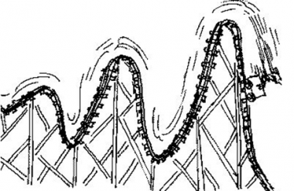

**Why did the Middle**

**Kingdom end?**

**Why did the Old**

**Kingdom end?**

**How the history of Egypt is like the rollercoaster on the right.**

**__________________________________________________________________________________________________________________________________________________________________________________________________________________________________________________________________________________________**

**Egyptian Politics definitions**

**Pharaoh:** _____________________________________________________________________________

**Dynasty:** _____________________________________________________________________________

**Absolute Power:** _______________________________________________________________________

**Regent:** ______________________________________________________________________________

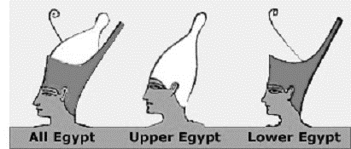

**Who was Menes? Why was he important?**

**____________________________________________________________________________________________________________**

Who was King Tutankhamen?

Why is he famous?

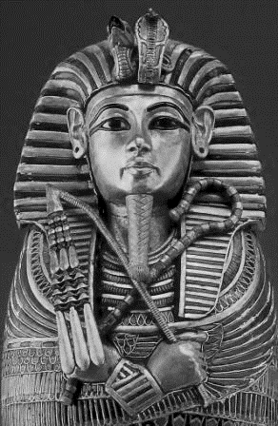



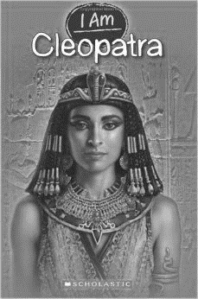

**EXPLAIN WHY EGYPT”S RULERS HAD MORE POWER THAT MOST RULERS TODAY:**

____________________________________________________________________________________________________________________________________________________________________________________________________________________________________________________________________________________________________________________________________________________