Name: __________________________
Religion in Ancient Egypt
1. What is the afterlife? ____________________________________________________
2. What happened during an Egyptian funeral? How is it similar to funerals today?
__________________________________________________________________________________________________________________________________________________________________________________________________________________________________________
3. Describe the Egyptian god/goddess below:
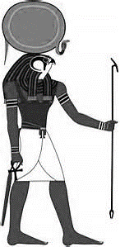  OSIRIS  AMON-RE | 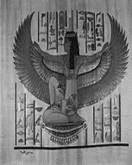  ISIS
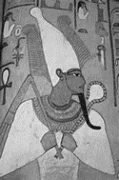 | 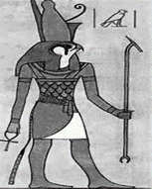  HORUS

4. Why were Egyptians buried with their belongings?
____________________________________________________________________________________________________________________________________________________________

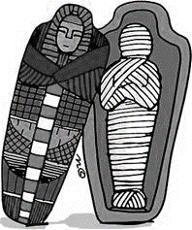
Why was I made?
__________________________________________________________________________________________________
How was I made?
________________________________________________________________________________________________________________________________________________________________________________________________________________
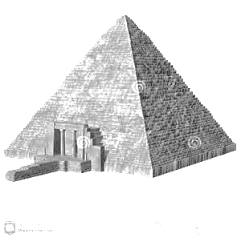

PYRAMID FACTS:
HOW MANY STONES? ________________
WEIGHT OF EACH STONE ________________
HOW LONG TO BUILD A PYRAMID? _______________
HOW DID STONE GET THERE?
_______________________________________________________________________________________________________________________________________
Great Pyramid
Who was I built for?

Where was I built?

EXPLAIN TWO WAYS WE KNOW THAT THE AFTERLIFE WAS IMPORTANT TO THE ANCIENT EGYPTIANS:
______________________________________________________________________________________________________________________________________________________________________________________________________________________________________________________________________________________________________________________________________________________________________________________________________

National Geographic: Egypt Underworld - Pathways to Eternity Video Notes
1. Why did Egyptian make mummies?
____________________________________________________________________________________
2. When the Pharaoh died he became who?
____________________________________________________________________________________
3. Where were the names of snakes that guarded the gates written?
____________________________________________________________________________________
4. Why were tombs considered portals to the afterlife?
____________________________________________________________________________________
5. Why was the archeologists stopped from entering Seti’s tomb in the 1960’s?
___________________________________________________________________________________
6. Why is Seti considered a great Pharaoh?
____________________________________________________________________________________
7. What kinds of things did Pharaoh put in there tombs to take with them in the Afterlife?
____________________________________________________________________________________
8. Who is Osiris and what does he do?
____________________________________________________________________________________
9. The shape of early step pyramids are thought to the stairways to the _________.
10. Why did the archeologist think the Pharaoh’s built all the rooms and tunnels in their pyramids?
____________________________________________________________________________________
11. Since later Pharaohs did not sacrifice people, how did they take servants with them to the Afterlife?
____________________________________________________________________________________
12. What is the Pharaoh’s job for all eternity? Why do you think this is?
_____________________________________________________________________________________

