Name: ______________________________________________________
Sumerian Cities: The First Cities
Directions: Read pgs. 33-35 and define the following key terms.
1. city-state: _________________________________________________________________________
____________________________________________________________________________________

2. ziggurat: _________________________________________________________________________
___________________________________________________________________________________

3. polytheism: ________________________________________________________________________
____________________________________________________________________________________

4. myths: ____________________________________________________________________________
____________________________________________________________________________________

Virtual Tour of UR:
Directions: While watching the tour notice what kinds of things the city of UR had. After the video, you must pretend you are talking with an early hunter-gather on his way to the city of UR. You must describe the city of UR to him to let him know what to expect before he visits.
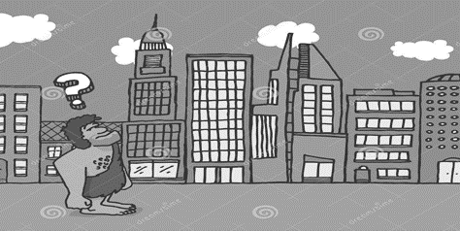
__________________________________________________________________________________________________________________________________________________________________________________________________________________________________________________________________________________________________________________________________________________________________________________________________________________________________________________________________________________________________________

Directions: While reading fill in the table below explaining what Sumerian cities had in common and what they had different.
SAME | DIFFERENT

5. Give 3 examples of ways Sumerians honored the gods.
________________________________________________________
________________________________________________________
________________________________________________________

6. Read the ancient Sumerian Poem
“Behold the bond of Heaven and Earth, the city…
Behold…its well of good water.
Behold…its pure canal”

Based on the poem what was important to the Sumerian? __________________________________
Why do you think this was so important? ________________________________________________
___________________________________________________________________________________
7. What caused the fall of Sumer?
______________________________________________________________________________________________________________________________________________________________________________________________________________________________________________________________________________________________________

8. Study the picture and read about Farming on pg36-37. Describe how farmers prepared the soil and planted their crops.
________________________________________________________________________________________________________________________________________________________________________________________________________________________________________________________________________________________________________________________________________________________________________________________________________

