Name: _________________________________________________
U.S. History Pre/Post Assessment
1. The Supreme Court's 1803 decision in Marbury v. Madison established the Court's power to
A. impeach a President
B. decide whether a federal law is constitutional
C. resolve conflicts between states
D. resolve conflicts between the President and Congress

2. Which group of Americans followed what has become known as the "Trail of Tears" when they were forced to leave their homes?
A. Japanese Americans
B. Irish Americans
C. Cherokee Indians
D. Mormons

3. Use the image below to answer part A & B
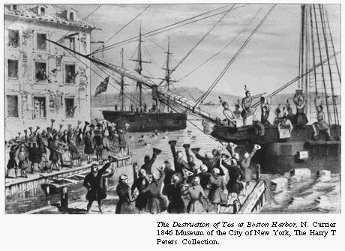
A. Identify the event that is portrayed in the picture above.

Boston Tea Party
B. Why is the event important in United States history?
It showed that the colonists were getting frustrated with British laws and taxes. It caused the British to crack down even more on colonists, eventually leading to the American Revolution.

4. American Indians taught European settlers how to grow
A. rice
B. sugar
C. tea
D. corn

5. What was the main reason that many leaders in Great Britain leaned toward supporting the Confederacy in the Civil War?
A. Plantation owners in Britain held slaves.
B. Most British immigrants to the United States lived in the South.
C. Britain relied on Southern cotton for its factories.
D. British politicians wanted to make the United States weaker so that they could conquer it.

6. Use the image below to answer the question below.
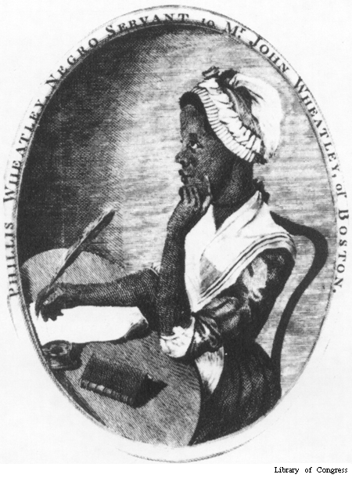
Using the picture and your knowledge of history, identify ONE way that Phillis Wheatley (1753-1784) was different from most slaves in the American colonies.

She could read and write, she was well dressed, she had leisure (relaxing time).

7. Which of these was one of the thirteen colonies that fought the American Revolution against the British?
A. Illinois
B. California
C. New York
D. Texas

8. The Oregon Trail was a
A. path taken by American Indians forced west in the 1800's
B. route on the Underground Railroad for escaped slaves
C. route taken by many settlers who traveled to the Northwest in the 1840's
D. border between territory held by Great Britain and the United States

9. “A house divided against itself cannot stand. I believe this government cannot endure permanently half slave and half free. I do not expect the Union to be dissolved—I do not expect the house to fall—but I do expect it will cease to be divided.”
What war broke out soon after the statement was made?
A. American Revolution
B. War of 1812
C. Mexican-American War
D. Civil War

10. Susan B. Anthony was a leader who helped
A. women win the right to vote
B. immigrants win the right to come to the United States
C. children win the right to an education
D. older people win the right to get social security

11. Use the graphs below to answer the following question:

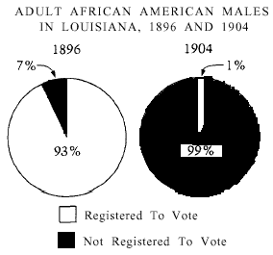
What explains the change in voter registration shown by these graphs?
A. New laws made it difficult for African Americans to vote.
B. Most African Americans were Democrats.
C. Most African Americans moved out of Louisiana.
D. The White population in Louisiana increased greatly.

12. During the 1500's and 1600's, what was the major cause of death among Indians of the Americas?
A. Warfare among tribes
B. Warfare between Native Americans and Europeans
C. Infections and diseases brought by Europeans
D. Changing climatic conditions

13. The Great Awakening of the 1730's was important because it led people in the American colonies to
A. increase toleration for Roman Catholics
B. examine the different positions of men and women in society
C. reaffirm that God gave kings their right to rule
D. question the authority of church and government leaders

14. What was one consequence of Nat Turner's rebellion?
A. Large numbers of slaves fled to the North.
B. Slave revolts broke out throughout the South.
C. Conditions for slaves on many southern plantations improved.
D. Southern states passed laws designed to tightly control slaves.

15. The Monroe Doctrine was intended to
A. promote United States trade with China
B. help keep the peace in Europe
C. discourage European involvement in the Americas
D. protect United States business in Japan and Korea

16. The establishment of the Virginia House of Burgesses contributed to which of the following?
A. The growth of political parties in colonial government
B. The increased authority of churches in political affairs
C. The increased authority of colonial governors over the colonies
D. The growth of self-government in colonial America

17. When the original thirteen states were considering ratification of the Constitution, there was much debate about whether or not the new form of government should be accepted.
One reason why some people voted in favor of ratifying the Constitution was:

The Federal Government was weak; unable to tax, provide a good military, and passing laws was extremely difficult under the Articles of Confederation.
One reason why some people voted against ratifying the Constitution was:
Many people were scared of a strong federal government, thought their individual rights would not be protected, thought the President would become a king.
18. The excerpt below is from the Declaration of Sentiments and Resolutions written at the 1848 Seneca Falls Convention.
We hold these truths to be self-evident: that all men and women are created equal; that they are endowed by their Creator with certain unalienable rights; that among these are life, liberty, and the pursuit of happiness . . .
In writing the Declaration of Sentiments, which document did the authors use to legitimize their claims and support their arguments?
A. The Declaration of Independence
B. The Articles of Confederation
C. The Bill of Rights
D. The Emancipation Proclamation
19. Use the map below to answer the following question:

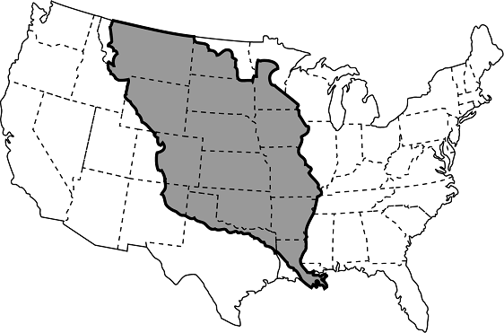
The shaded area on the map above shows which of the following?
A. The territory controlled by Spain during the 1600s
B. The Louisiana Purchase of 1803
C. The extension of slavery during the 1800s
D. The territory closed to westward expansion in 1763 due to conflict with Native Americans

20. Which of the following people were most likely to become indentured servants in the English colonies?
A. Convicted criminals sent to the colonies to work off their sentences
B. Puritans seeking religious freedom and a job working for a religious family
C. Poor workers willing to trade their labor for passage to America
D. Freed slaves who could not yet afford to buy their own farms or start businesses

21. The first permanent English settlement in North America was
A. St. Augustine
B. Santa Fe
C. Jamestown
D. New Amsterdam

22. Four events are listed below.
A Colonists meet in Philadelphia and declare independence.
B Roanoke Island is settled by English settlers.
C George Washington becomes the first President.
D English Parliament passes Stamp Act.

Write the letters that are next to the four events in the squares on the time line below in the order that the events happened, from earliest to latest. Be sure that you put only one letter in each square.

Earliest to Latest B D A C
.

23. What impact did the Anti-Federalists have on the United States Constitution?
A. Their arguments helped lead to the adoption of the Bill of Rights.
B. Their arguments helped lead to the abolition of the slave trade.
C. Their influence ensured that the federal government would maintain a standing army.
D. Their influence ensured that the federal government would have the power to tax.

24. One major consequence of the Seven Years' War (French and Indian War) was that the
A. colonists' decision to side with France led Britain to retaliate against them
B. expense of fighting the war led Britain to tax the colonies directly for the first time
C. loyalty of the colonists to the British side led Britain to grant them a high degree of self-government
D. elimination of the French threat in North America led Britain to concentrate on conquering all of the remaining Spanish colonies

25. During the Revolutionary War, one outcome of the colonial victory at the Battle of Saratoga that helped ensure the final defeat of the British was the
A. entrance of France on the American side
B. recapture of New York City from the British
C. mutiny of the British forces under General Howe
D. defeat of British forces at Valley Forge, Pennsylvania

26. Question refers to the passage below.
“We hold these truths to be self-evident: That all men are created equal; that they are endowed by their Creator with certain unalienable rights; that among these are life, liberty, and the pursuit of happiness. That, to secure these rights, governments are instituted among men, deriving their just powers from the consent of the governed; that, whenever any form of government becomes destructive of these ends, it is the right of the people to alter or to abolish it, and to institute a new government.”—1776
The quotation is from the
A. Articles of Confederation
B. Constitution
C. Declaration of Independence
D. Missouri Compromise

27. Explain why the framers of the Constitution established a system of checks and balances among the three branches of government.
To make sure that one branch of government did not become too powerful.

28. What is the main reason the Pilgrims and Puritans came to America?
A. To practice their religion freely
B. To make more money and live a better life
C. To build a democratic government
D. To expand the lands controlled by the king of England

29. The Constitution requires that the President's nominations to the Supreme Court be approved by the Senate. This is an example of
A. legislative supremacy
B. federalism
C. checks and balances
D. judicial review

30. Question refers to the passage below.
“When two [people] come into [the Supreme] Court, one may say: "an act of Congress means this." The other may say it means the opposite. We [the Court] then say it means one of the two or something else in between. In that way we are making the law, aren't we?” — Earl Warren, Chief Justice of the Supreme Court
The function of the Court that Chief Justice Warren described is called
A. judicial restraint
B. advise and consent
C. judicial review
D. impeachment

31. Congress has been able to expand the powers of the federal government based largely on its authority to
A. coin money
B. govern the District of Columbia
C. declare war
D. make all laws necessary to perform its duties

32. In a market economy, most decisions about which goods and services to produce, how to produce them, and who will consume them are made primarily by which of the following?
A. The national government
B. Industry planning groups
C. Local and state governments
D. Consumers and producers

33. Use the following Amendment to answer the question below:
AMENDMENT 4. SEARCHES AND SEIZURES
“The right of the people to be secure in their persons, houses, papers, and effects, against unreasonable searches and seizures, shall not be violated, and no warrants shall issue, but upon probable cause, supported by Oath or affirmation, and particularly describing the place to be searched, and the persons or things to be seized.”
Which of the following is true because of the Fourth Amendment?
A. There are legal limits on the power of police to enter your home.
B. You have the right to speak to a lawyer before answering police questions.
C. Police must be certain a crime has been committed before getting a search warrant.
D. You may never be tried for the same crime twice.

34. Which of the following best describes the primary role of an economic system?
A. To respond to market failure
B. To address equity concerns to improve fairness
C. To determine the allocation of limited resources
D. To protect domestic producers from foreign competition

35. Use the graphic organizer below to answer the following question:
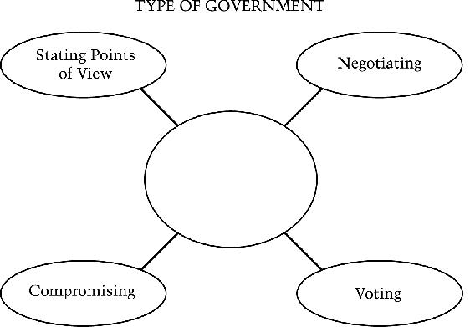
Which of the following types of government best fits in the blank in the diagram above?
A. Authoritarian
B. Democracy
C. Absolute monarchy
D. Military dictatorship

