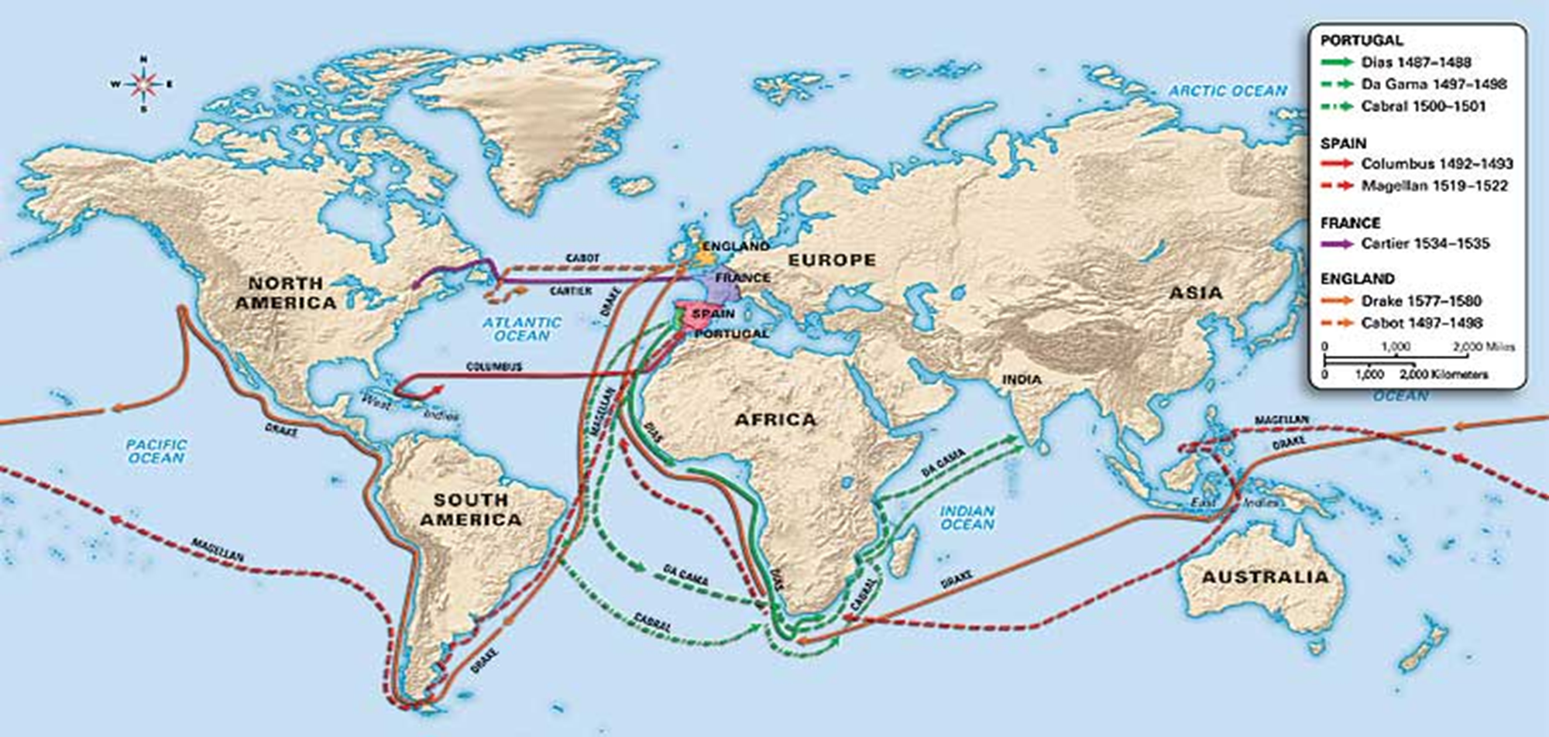
Map of European Exploration
Name: _______________________________________________________

When and Who of European Exploration
Directions: Study the map of European Exploration and record when each country traveled to the Americas and where they went.
Country | When? | Who?
Spain
Portugal
France
England

