Name: __________________________________________
World History Pre/Post Assessment

1. Which development most enabled early peoples to form permanent settlements?
- advances in agriculture
- the creation of democratic government
- the spread of monotheism
- advances in written language

2. Hammurabi’s Code of ancient Mesopotamian society was important because it
- brought order to society with laws and punishments
- explained how government officials were chosen.
- established a single currency for use across the empire.
- described how to perform formal religious ceremonies.

3. Use the image below to answer the following question:
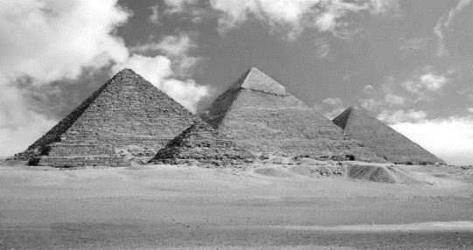
The Egyptian structures seen above were constructed to
- practice religion ceremonies
- give slaves a cheap place to live
- used a palaces for Egyptian nobles
- protect the tombs of the Pharaohs

4. Cuneiform and hieroglyphics were important achievements in the development of
- written language
- religious beliefs
- agricultural production
- representative government
5. What belief do the Jewish, Christian, and Muslim religions have in common?
A Mecca
B monotheism
C Mosiac law
D belief that Jesus is the son of God

6. The diaspora, the dispersing of the Jewish people refers to their
- effort to convert nonbelievers
- collection of their sacred writings
C exile from their homeland
D opposition to the Crusades

7. Greece’s mountainous terrain and its series of small islands influenced the Greeks to develop
- independent city-states
- a common culture
- a coin economy
D a strong military

8. Ancient Greeks used myths about their gods primarily to
- strike fear in their enemies.
- explain events in the natural world.
- justify their type of government.
- undermine the Persian religion.

9. Archeologists study:
A. maps
B. artifacts
C. laws
D. buildings

10. Use the map below to answer the following question:
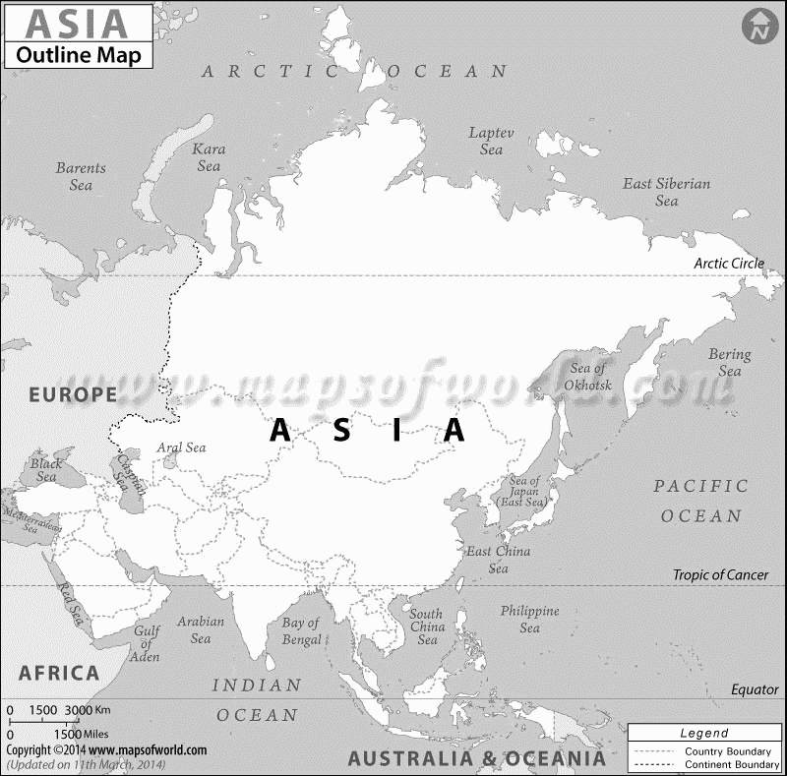
D
C
B
A
Which letter on the map above was the location of the Indus River Valley civilization?
A. Location A
B. Location B
C. Location C
D. Location D

11. Use the image below to answer parts A & B:
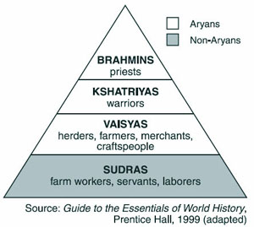
A. This caste system was practiced by what ancient civilization?
A. Egyptian
B. Babylonian
C. Mayan
D. Aryan

B. Which statement about this caste system is accurate?
- Different castes shared the same rules for governing their behavior.
- Foreigners were treated as members of the lowest caste.
C People were required to stay in the same caste to which they were born.
D Castes were encouraged to interact with one another.

12. What was the main contribution of Emperor Shi Huangdi to China?
- He unified most of China under one government.
- He established a public education system in China.
- He required citizens to use the Mongol language.
- He encouraged acceptance of the Hindu religion.

13. What is the name of the river that flows through Egypt?
A. Nile
B. Mediterranean
C. Red
D. Sahara

14. What helped historians understand ancient Egyptian hieroglyphics?
A. Rosetta Stone
B. King Tut’s tomb
C. algebra
D. studying sarcophagi

15. In the 700s A.D., Arabian merchants played an important role in
- spreading new technology among Asia, Africa, and Europe.
- converting large numbers of Western Europeans to Islam.
- uniting most of Asia and Europe under a single religion.
- stopping the invasions of nomadic people from Central Asia.

16. What were the people who were paid to write for a living called?
A. priests
B. merchants
C. law givers
D. scribes

17. What is the best description of the relationship between the Mesopotamian city-states?
A. always fighting over land, power, and wealth
B. always ruled by a single leader
C. peaceful after the invention of writing
D. took turn voting for kings to rule

18. Use the image below to answer the following question:
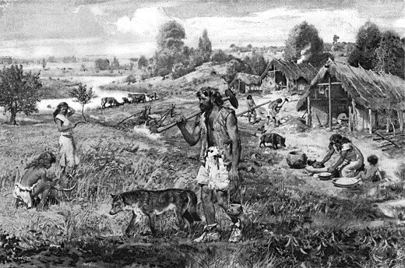
This image illustrate which time period during the prehistoric Stone Ages
A. Paleolithic
B. Mesolithic
C. Neolithic

19. The system of levees and canals used to divert water to crops is called .
A. irrigation
B. agriculture
C. specialization
D. ziggurats

20. One of the great achievements of the Indus Valley civilization was
A. number system
B. invention of the chariot.
C. iron technology.
D. plumbing and sewage system.

21. In ancient Sparta, which activity was a defining feature of citizenship for men?
A. paid taxes
B. attended religions events
C. attended political assemblies
D. fought in the military

22. What is the best definition of karma?
A. being reborn after you die
B. worship like prayer, hymns, or offerings
C. your actions have good or bad effects
D. going to heaven when you die

23. People who move from place to place and have no permanent home are called
A. artisans
B. nomads
C. yurts
D. laden

24. The 5 MAJOR Inventions in Ancient China are...
A. fireworks, silk, bronze, kites, watch
B. bronze, fireworks, cotton, silk, kites
C. fireworks, silk, bronze, kites, compass

25. The Vedas are a
A. mountain range in northern India.
B. nomadic herders in the Indus Valley
C. Aryan religious books
D. early inhabitants of India

26. Use the image to help you answer the question below:
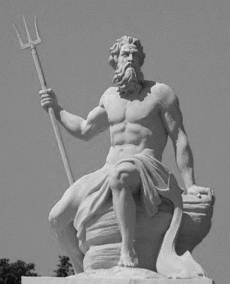
The god of the sea, Poseidon, was worshipped in by which ancient culture?
A. Sumerians
B. Greeks
C. Egyptians
D. Chinese

27. Why were many people in ancient Greece traders or ship builders?
A. it paid them well
B. Greece is located near the sea
C. they couldn't find other jobs
D. they wanted a large navy

28. Democracy means government:
A. By the people
B. By the king
C. By nobles
D. By the military

29. When the river flooded in the Indus Valley, what valuable natural substance was left behind when the waters receded?
A. limestone
B. rocks
C. clay
D. silt
30. Use the map to answer the following question:
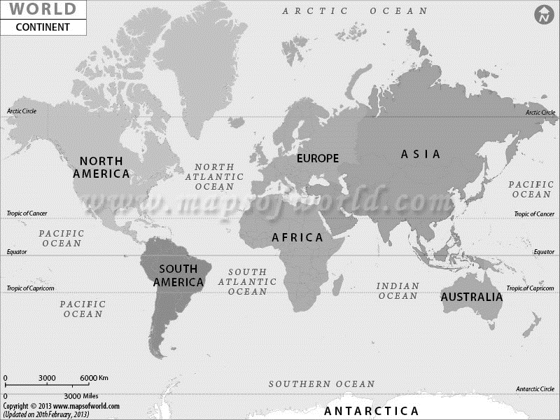
Which continents produced the first civilizations, first towns and first new ideas?
A. Europe and Antarctica
B. South America and North America
C. Africa and Asia
D. Europe and Russia

31. Use the map below to answer the following question:
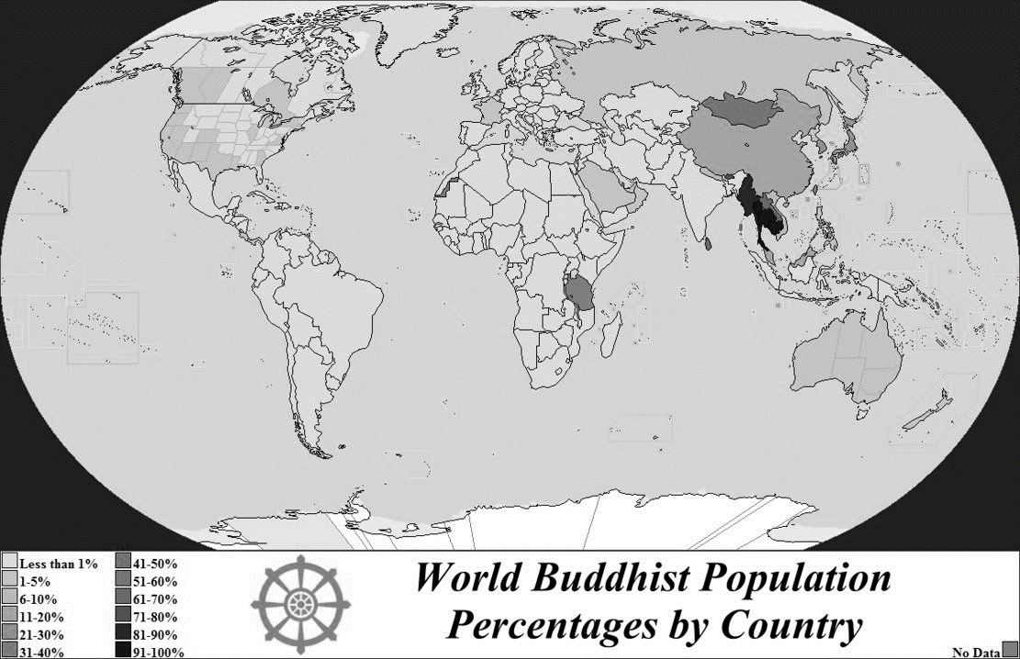
Which major world religion would you most likely find in the circled region of the map above?
A. Christianity
B. Judaism
C. Islam
D. Buddhism

32. The Great Wall of China was built to —
A. close China to foreign trade
B. provide a trade route across Asia
C. protect China from invaders
D. create a monument to Mongol rule

33. Buddhists achieve enlightenment by following the —
A. laws of the Old Testament
B. decrees of the Upanishads
C. Five Pillars
D. Eightfold Path

34. Read the following quote and answer the question below:
“An Athenian citizen does not put private affairs before affairs of the state; even our merchants and businessmen know something about politics. We alone believe that a man who takes no interest in public affairs is more than harmless; he is useless.” –Pericles
In this quotation, Pericles describes Athenian society as valuing —
A. military discipline
B. political duties
C. religious freedom
D. economic opportunity

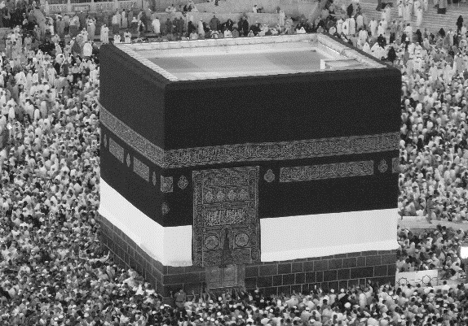
35. Which religion encourages its followers to make a pilgrimage to this site?
A. Islam
B. Hinduism
C. Buddhism
D. Christianity

36. Use the map below to answer the following question:
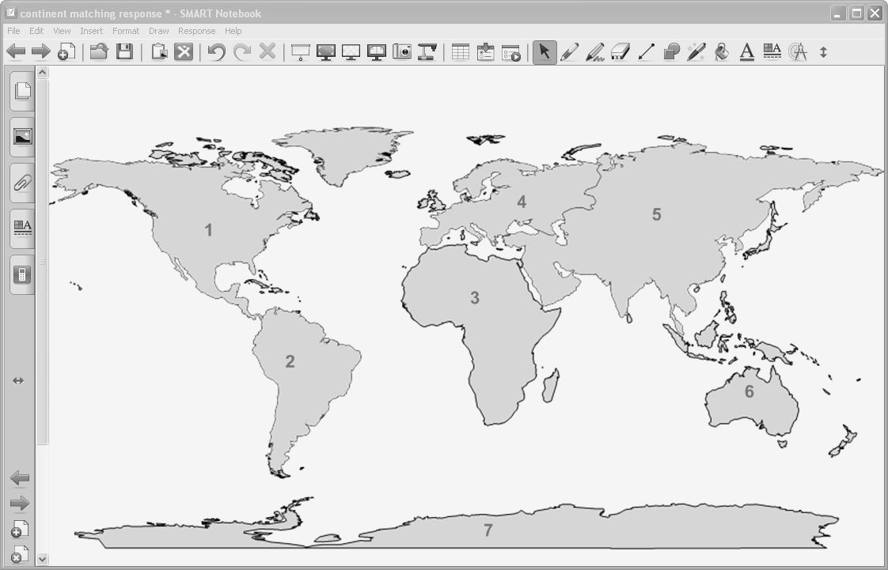
Which number on this map represents the region where archaeologists believe the first humans appeared?
A. 1
B. 2
C. 3
D. 4

37. The Silk Road was important because it allowed for the
A. exploration of China by the Roman Army
B. exchange of goods and ideas between Asia and the West
C. movement of Chinese armies through Southeast Asia
D. development of agriculture by the nomadic people of Central Asia

38. Which text is a central document of Judaism?
A. Analects
B. Koran (Qur’an)
C. Torah
D. Upanishads

