Name: __________________________________________
8TH Grade World History Pre/Post Assessment

1. Which development most enabled early peoples to form permanent settlements?
- advances in agriculture
- the creation of democratic government
- the spread of monotheism
- advances in written language

2. Hammurabi’s Code of ancient Mesopotamian society was important because it
- brought order to society with laws and punishments
- explained how government officials were chosen.
- established a single currency for use across the empire.
- described how to perform formal religious ceremonies.

3. Use the image below to answer the following question:
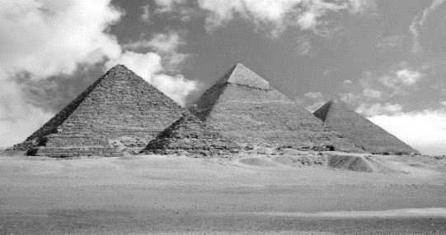
The Egyptian structures seen above were constructed to
- practice religion ceremonies
- give slaves a cheap place to live
- used a palaces for Egyptian nobles
- protect the tombs of the Pharaohs

4. Cuneiform and hieroglyphics were important achievements in the development of
- written language
- religious beliefs
- agricultural production
- representative government
5. What is the main reason that European countries went to the New World?
A. resources and water routes to Asia
B. conquer the Native Americans
C. spread Christianity throughout the world
D. acquire more farmland to produce crops

6. When Walter Raleigh returned to the Roanoke colony he found all of the following but
A. the houses had been dismantled
B. evidence that Natives attacked
C. words carved on posts
D. evidence that Natives had taken colonists belongings

7. Which is NOT a major problem the Jamestown colonists encountered when arriving in the New World?
A. diseases like malaria
B. laziness of Englishmen
C. attacks from Natives
D. weak leaders like John Smith

8. What had the biggest impact on the colony of Jamestown?
A. good farmland
B. discovery of gold
C. planting of tobacco
D. trade with the Natives

9. Archeologists study:
A. maps
B. artifacts
C. laws
D. buildings

10. Use the map below to answer the following question:
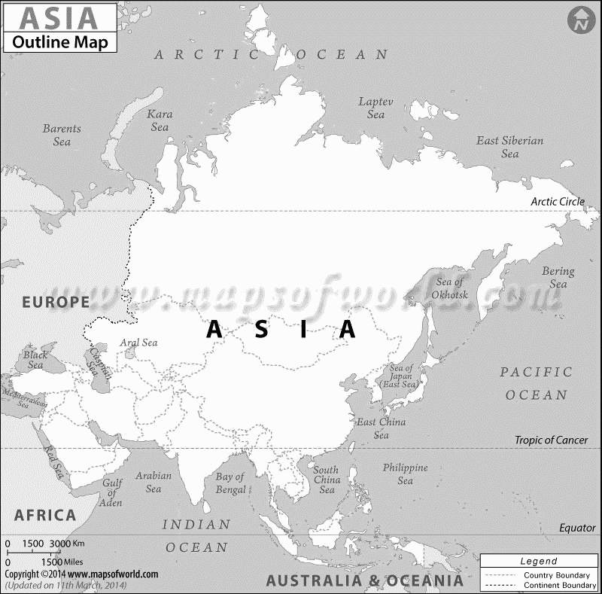
D
C
B
A
Which letter on the map above was the location of the Indus River Valley civilization?
A. Location A
B. Location B
C. Location C
D. Location D

11. Use the image below to answer parts A & B:
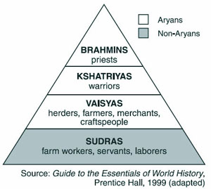
A. This caste system was practiced by what ancient civilization?
A. Egyptian
B. Babylonian
C. Mayan
D. Aryan

B. Which statement about this caste system is accurate?
- Different castes shared the same rules for governing their behavior.
- Foreigners were treated as members of the lowest caste.
C People were required to stay in the same caste to which they were born.
D Castes were encouraged to interact with one another.

12. What was the main contribution of Emperor Shi Huangdi to China?
- He unified most of China under one government.
- He established a public education system in China.
- He required citizens to use the Mongol language.
- He encouraged acceptance of the Hindu religion.

13. What is the name of the river that flows through Egypt?
A. Nile
B. Mediterranean
C. Red
D. Sahara

14. What helped historians understand ancient Egyptian hieroglyphics?
A. Rosetta Stone
B. King Tut’s tomb
C. algebra
D. studying sarcophagi

15. In the 700s A.D., Arabian merchants played an important role in
- spreading new technology among Asia, Africa, and Europe.
- converting large numbers of Western Europeans to Islam.
- uniting most of Asia and Europe under a single religion.
- stopping the invasions of nomadic people from Central Asia.

16. What were the people who were paid to write for a living called?
A. priests
B. merchants
C. law givers
D. scribes

17. What is the best description of the relationship between the Mesopotamian city-states?
A. always fighting over land, power, and wealth
B. always ruled by a single leader
C. peaceful after the invention of writing
D. took turn voting for kings to rule

18. Use the image below to answer the following question:
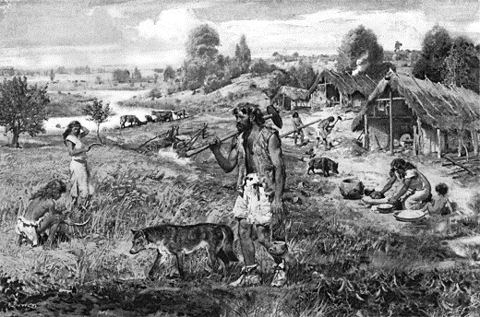
This image illustrate which time period during the prehistoric Stone Ages
A. Paleolithic
B. Mesolithic
C. Neolithic

19. The system of levees and canals used to divert water to crops is called .
A. irrigation
B. agriculture
C. specialization
D. ziggurats

20. One of the great achievements of the Indus Valley civilization was
A. number system
B. invention of the chariot.
C. iron technology.
D. plumbing and sewage system.

21. Colonists were upset by the British taxes on the colonies. One of the main reasons they were upset by these taxes was because…
A. colonists did not benefit from the French and Indian Wars
B. the American colonies were too poor to pay the taxes
C. the American colonies had no representation in British Parliament
D. only some of the colonists had to pay these taxes

22. What impact did the Boston Massacre have on the British colonists in North America
A. made colonists realize they could fight the British
B. angered colonists and united them against the British
C. made colonist boycott buying British tea
D. saddened colonists and made many move away from Boston

23. People who move from place to place and have no permanent home are called
A. artisans
B. nomads
C. yurts
D. laden

24. The 5 MAJOR Inventions in Ancient China are...
A. fireworks, silk, bronze, kites, watch
B. bronze, fireworks, cotton, silk, kites
C. fireworks, silk, bronze, kites, compass
25. What is the name of the document that ended the American Revolution and granted the United States all the land south of Canada?
A. Common Sense
B. Declaration of Independence
C. Treaty of Paris
D. U.S. Constitution

26. Trapped between the Continental Army and the French fleet, the final British defeat occurred at which battle?
A. Trenton
B. Yorktown
C. Saratoga
D. Long Island

27. Study the map of the Battle of Trenton below.
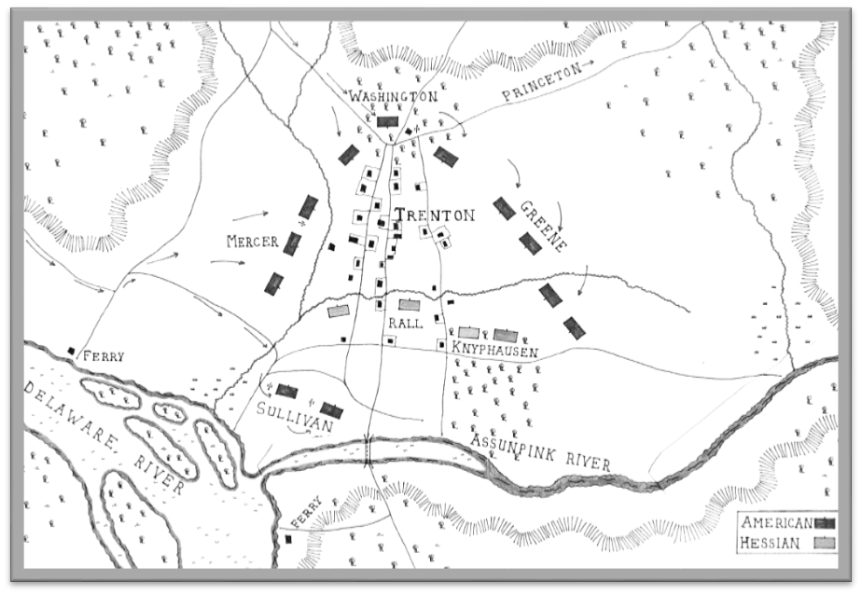
How did Americans feel about George Washington after the battle?
A. He was a strong and intelligent military leader
B. His lack of battle plans would lose the war
C. He did not have the respect of his soldiers
D. He was sneaky and not to be trusted
28. Democracy means government:
A. By the people
B. By the king
C. By nobles
D. By the military

29. When the river flooded in the Indus Valley, what valuable natural substance was left behind when the waters receded?
A. limestone
B. rocks
C. clay
D. silt
30. Use the map to answer the following question:
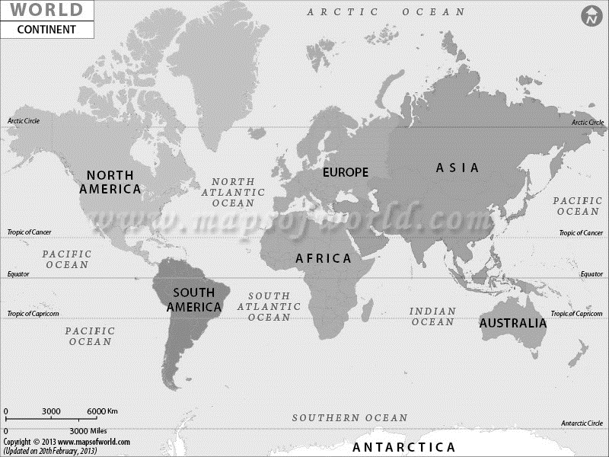
Which continents produced the first civilizations, first towns and first new ideas?
A. Europe and Antarctica
B. South America and North America
C. Africa and Asia
D. Europe and Russia

31. What power does the President have as head of the Executive Branch?
A. appoint supreme court justices and cabinet members
B. decides what a laws means
C. collect taxes
D. declares laws unconstitutional

32. The Great Wall of China was built to —
A. close China to foreign trade
B. provide a trade route across Asia
C. protect China from invaders
D. create a monument to Mongol rule

33. All are jobs of the Legislative Branch EXCEPT
A. declare war
B. approve presidential appointments
C. collect taxes
D. enforce the laws

34. Which of the following is NOT protected by the first amendment?
A. freedom of speech
B. freedom of religion
C. right to bear arms
D. right to peaceful protest
35. Which is one way the U.S. Constitution may be amended?
A. Supreme Court can make changes
B. Congress may propose amendments
C. The President can impose changes
D. Voters can write in changes on ballots

36. Use the map below to answer the following question:
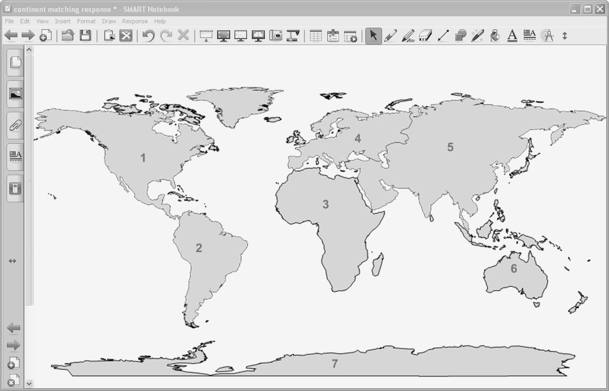
Which number on this map represents the region where archaeologists believe the first humans appeared?
A. 1
B. 2
C. 3
D. 4

37. The Silk Road was important because it allowed for the
A. exploration of China by the Roman Army
B. exchange of goods and ideas between Asia and the West
C. movement of Chinese armies through Southeast Asia
D. development of agriculture by the nomadic people of Central Asia

38. Which of the following statements is true about what was included in the Declaration of Independence?
A. Bill of Rights
B. list of bad things that the King of England had done to the colonies
C. list of the three branches of government
D. threat that the colonies would take over the country of Britain

